**PROJECT 1:**

**VPC peering**

Ss1: VPCs list

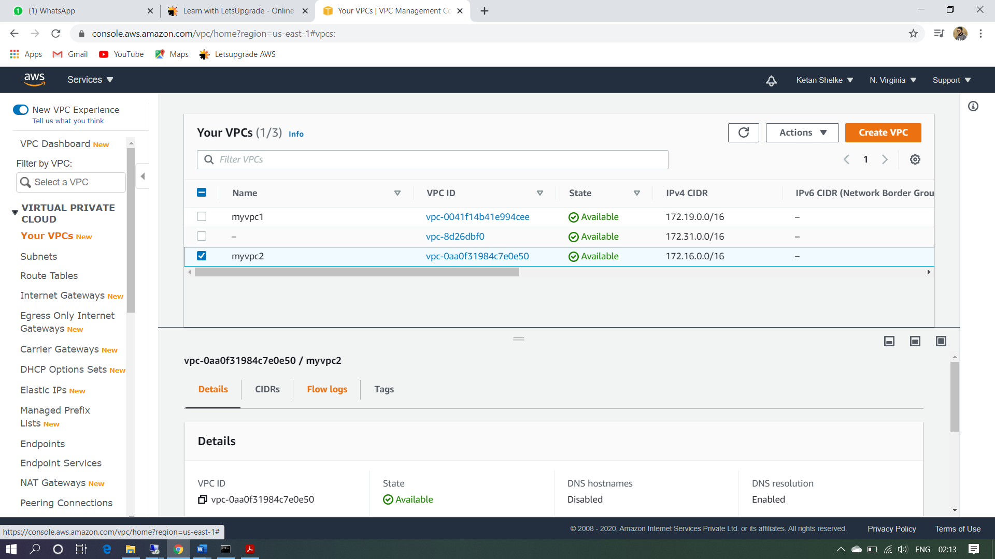

Ss2: Internet Gateways list

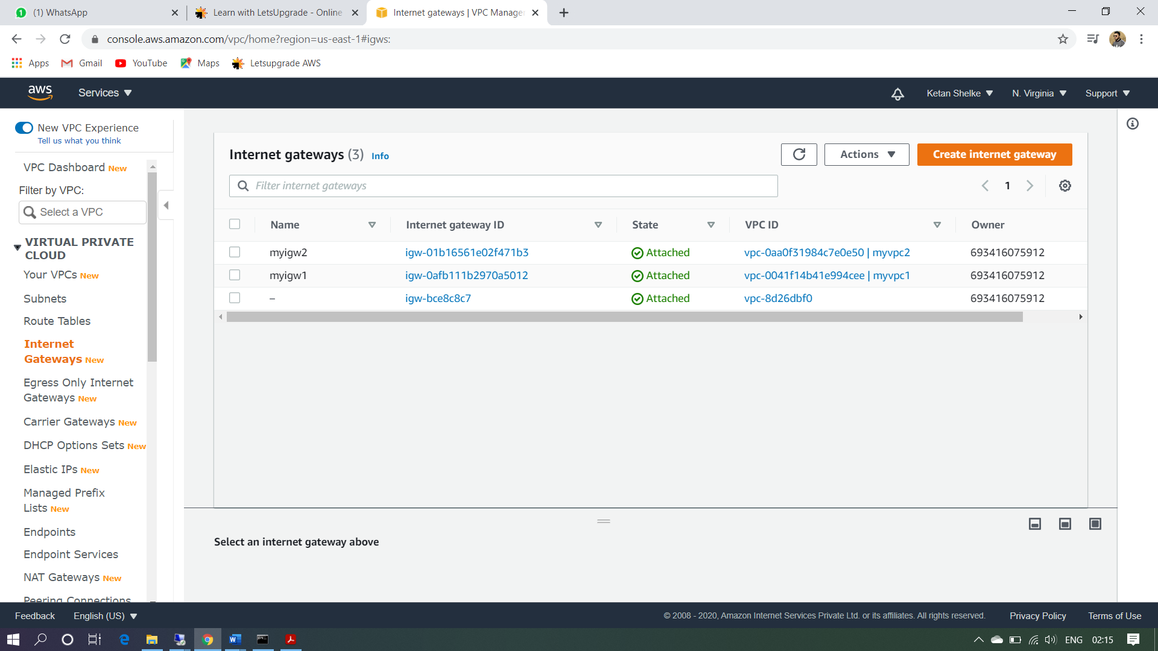

Ss3: edit route list

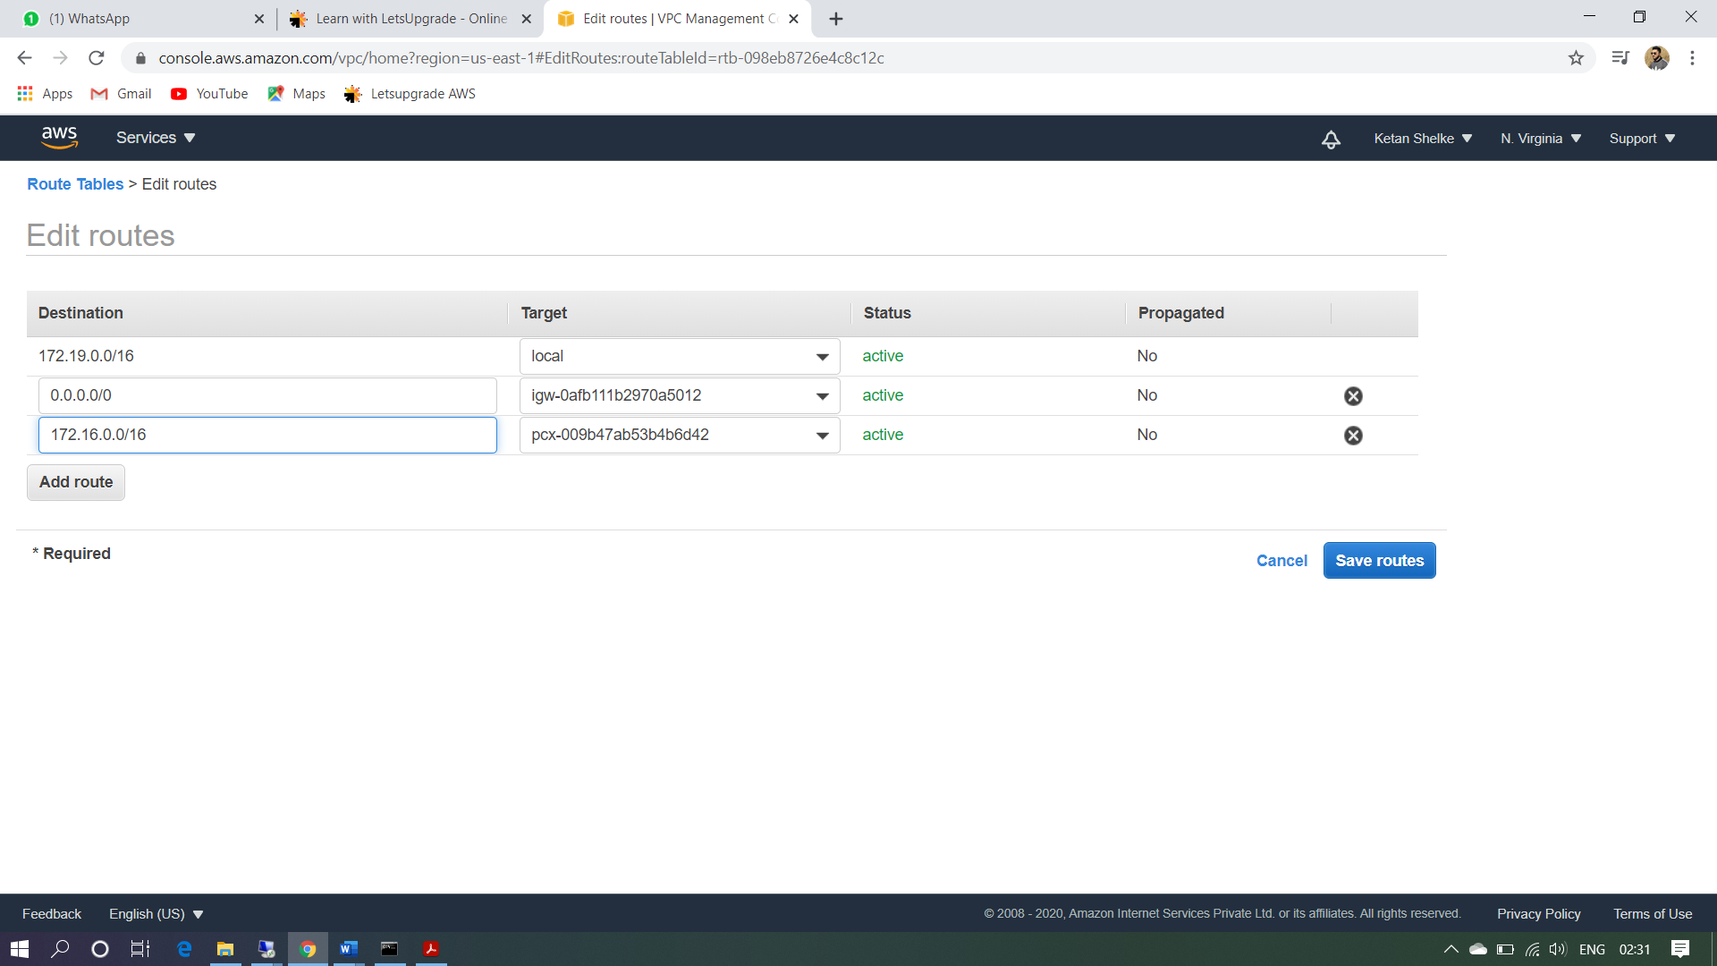

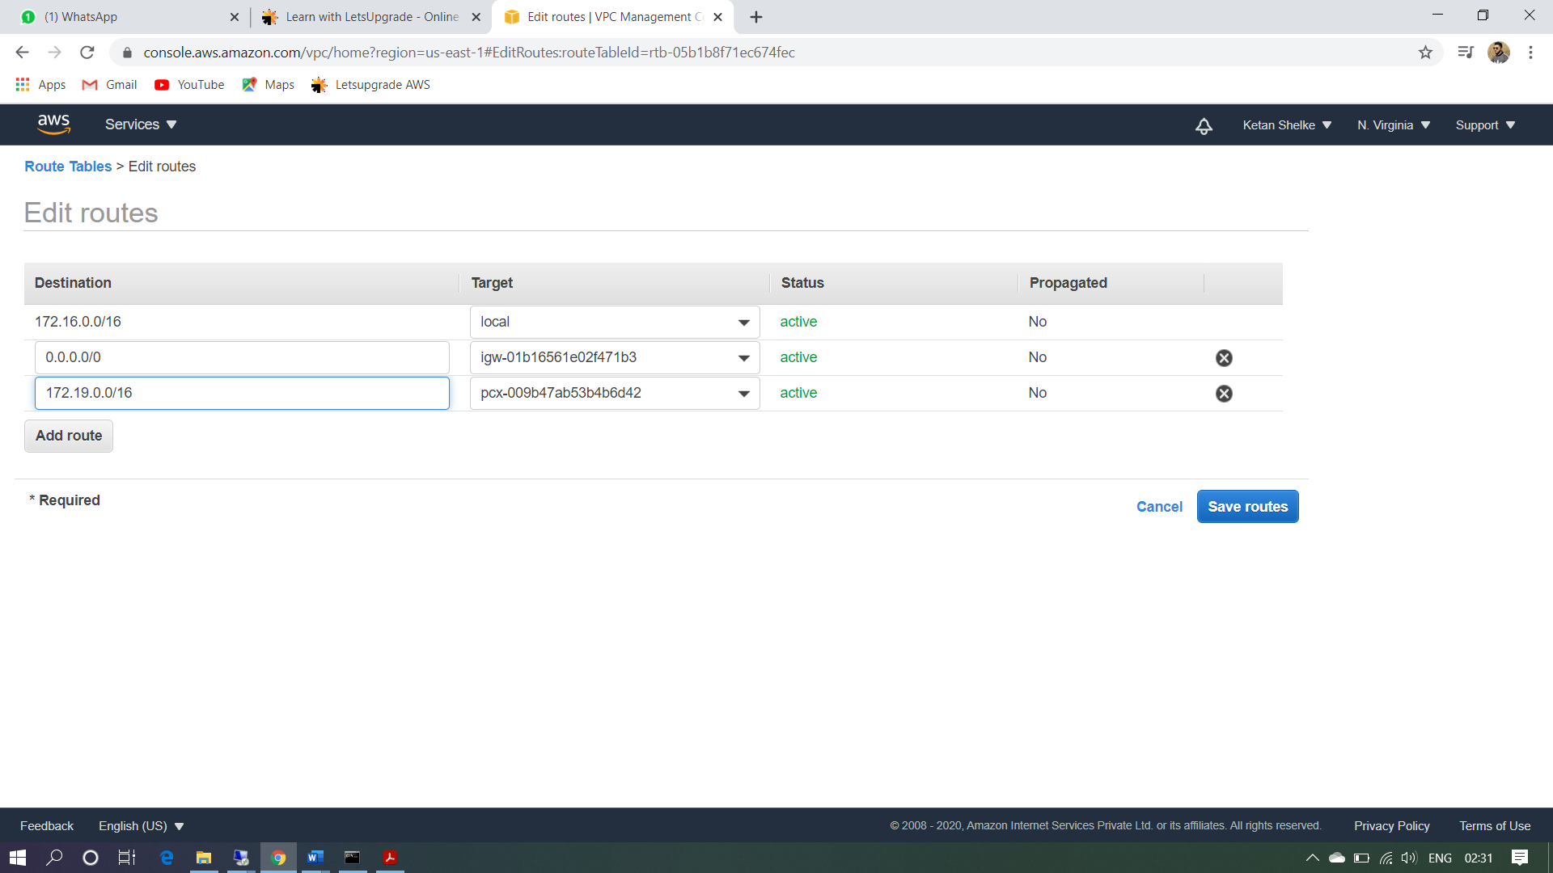

Ss4: subnet list

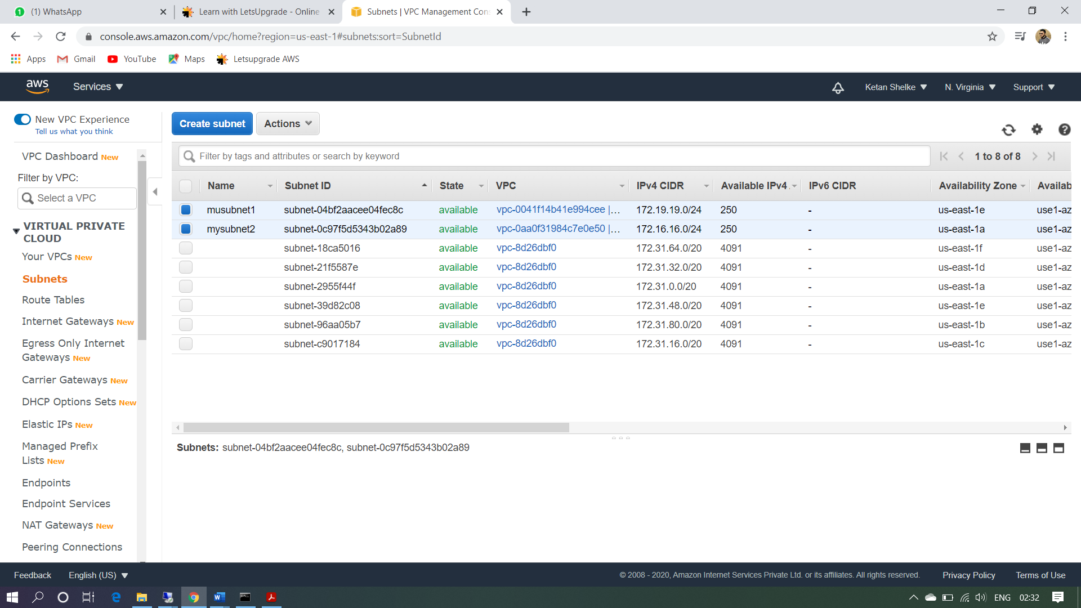

Ss5: instance details

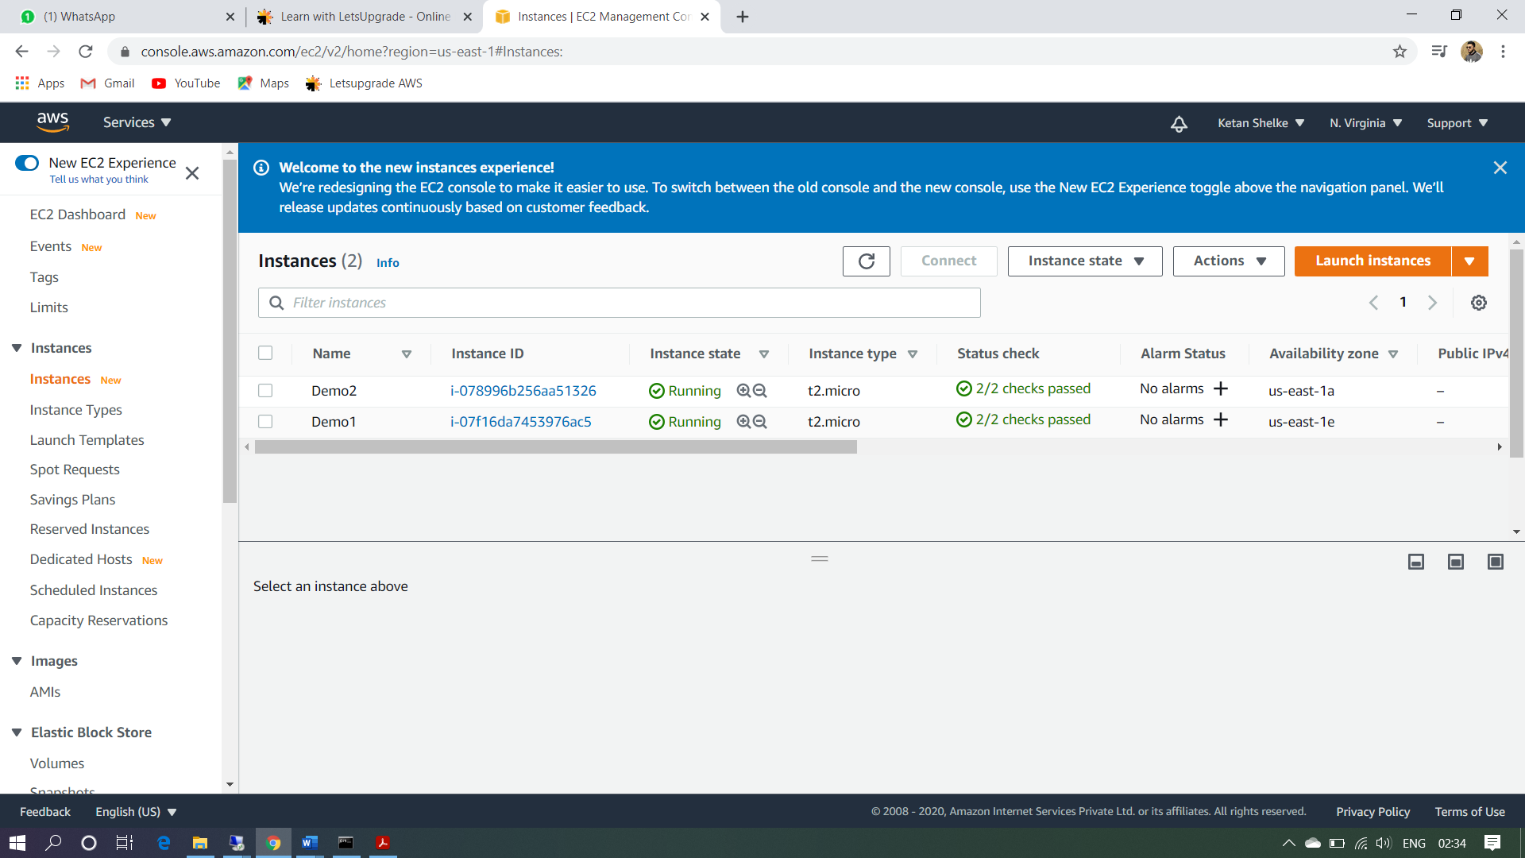

Ss7: peering with requestor and acceptor

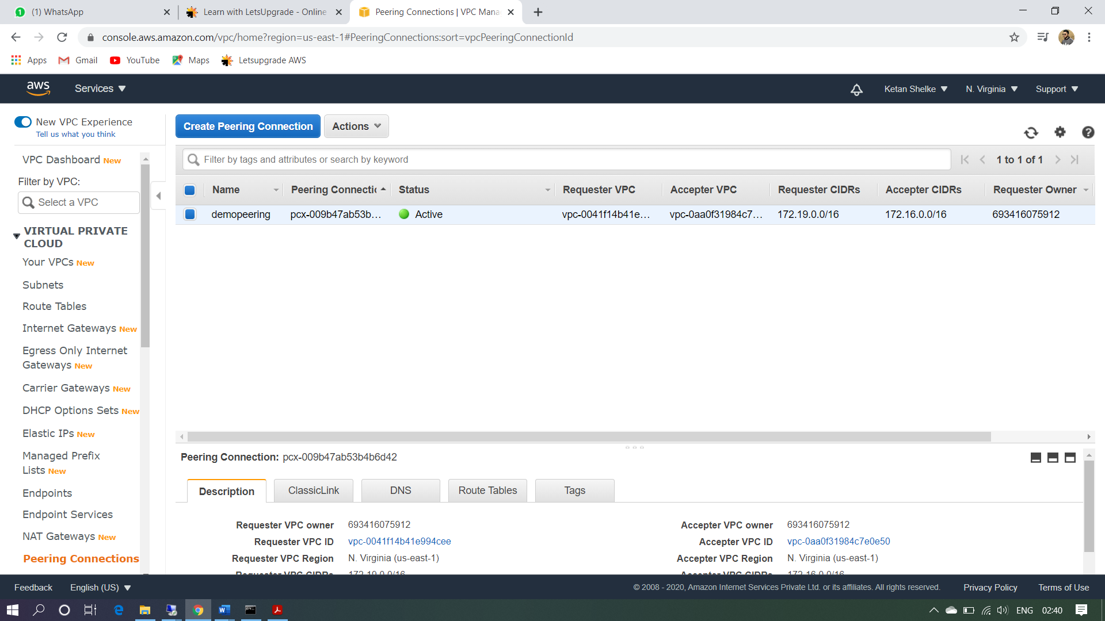

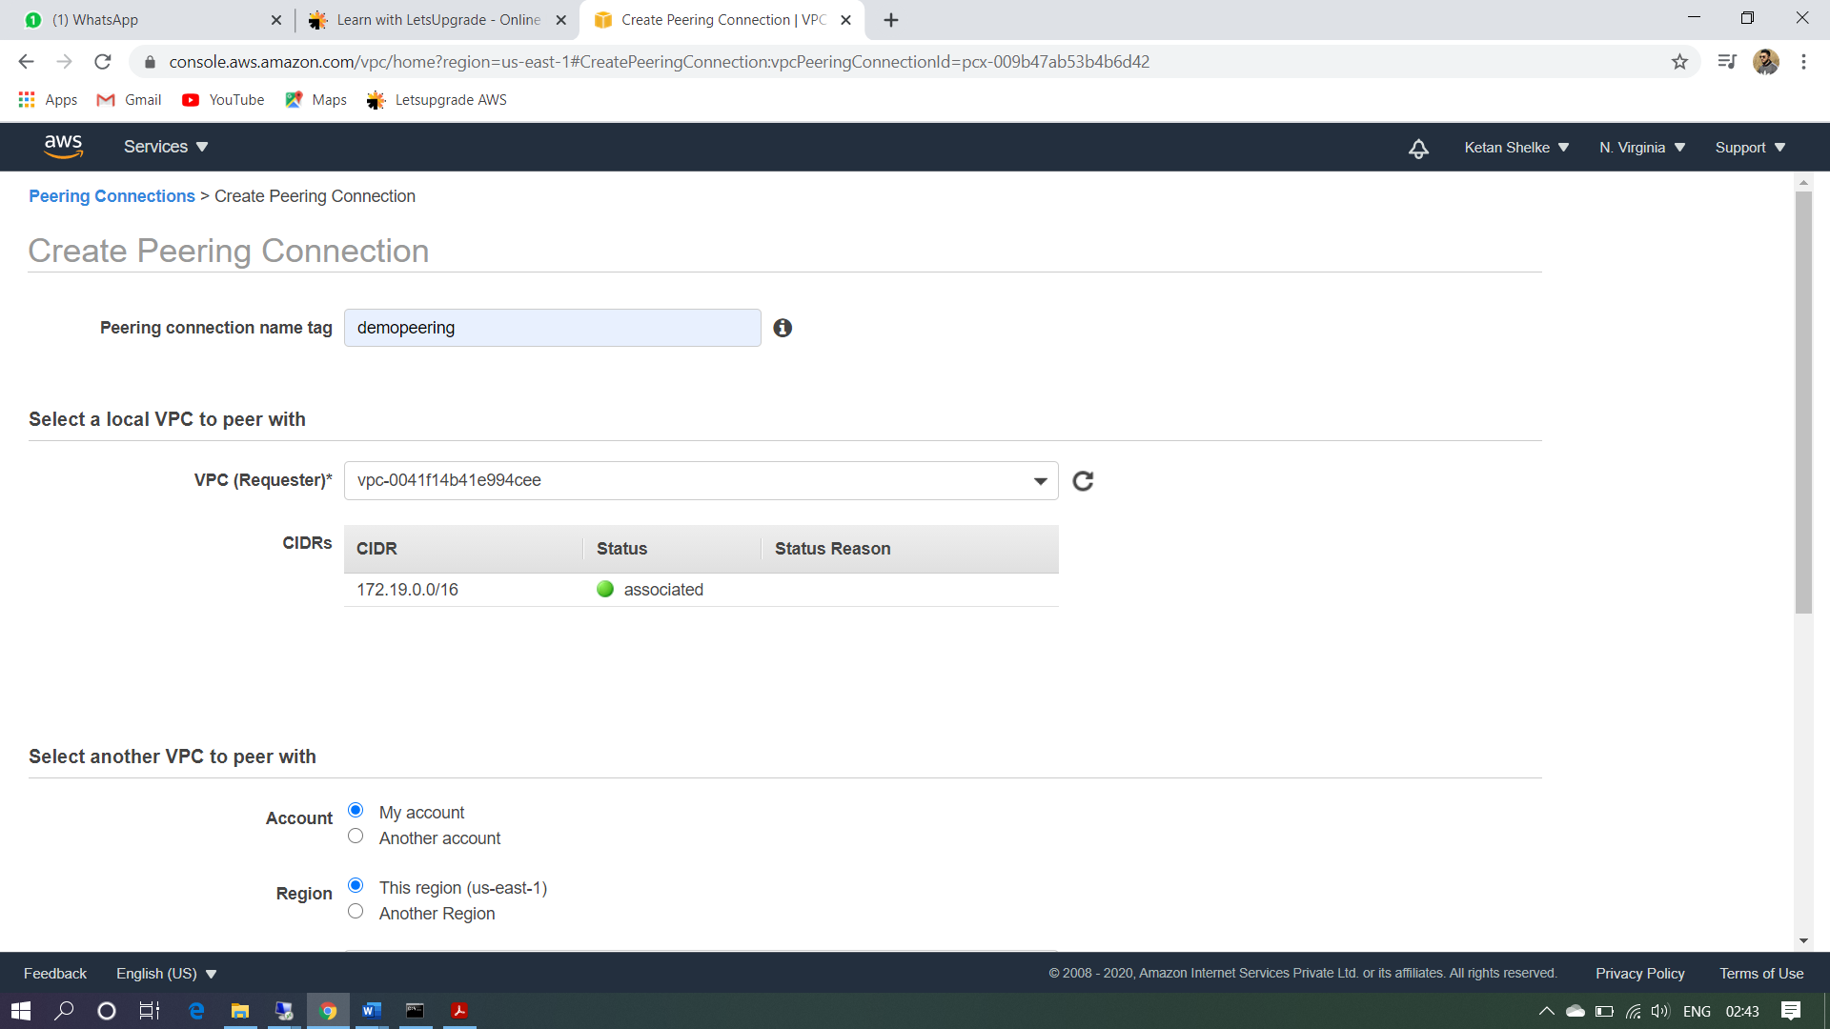

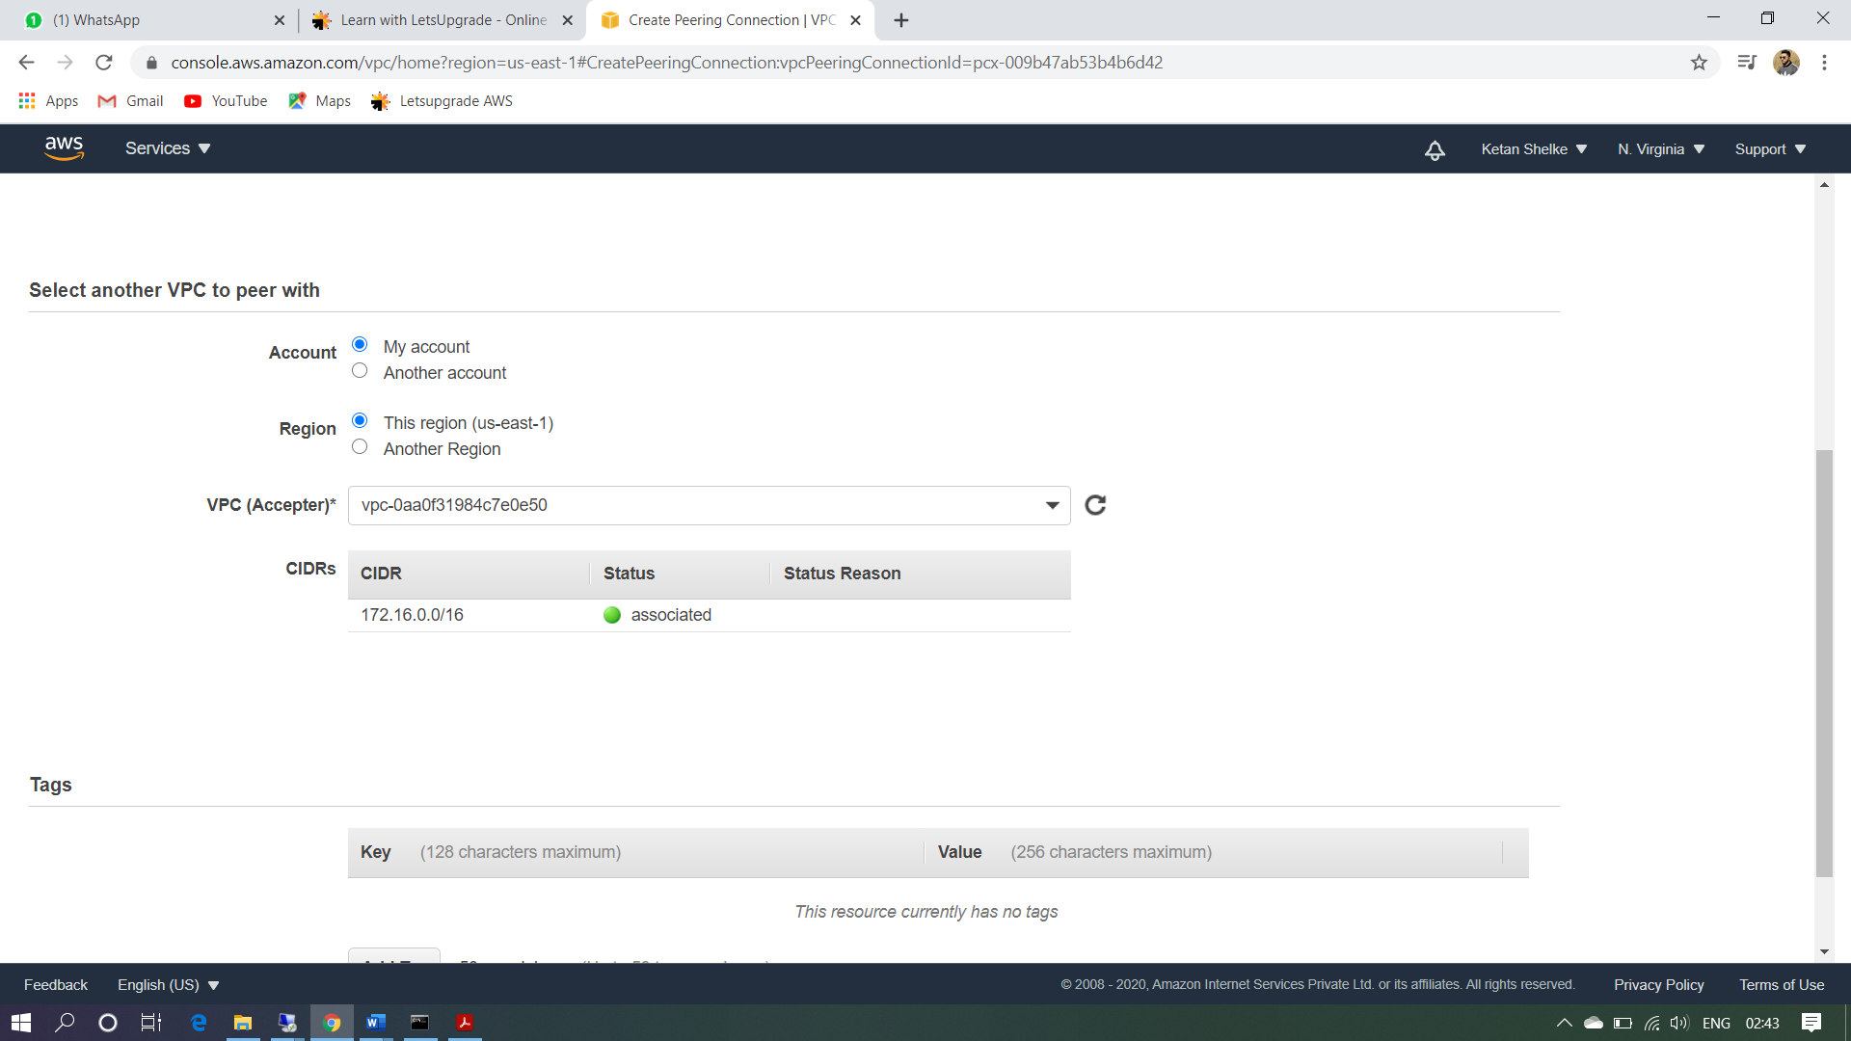

Ss6: success public, rto private IP

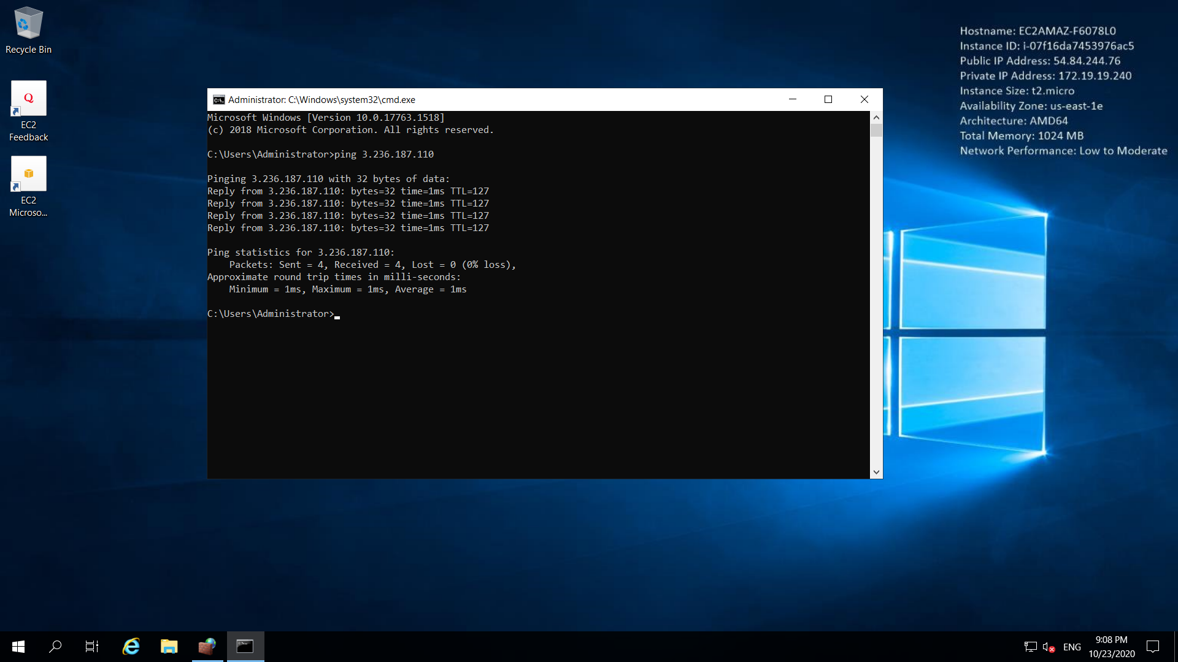

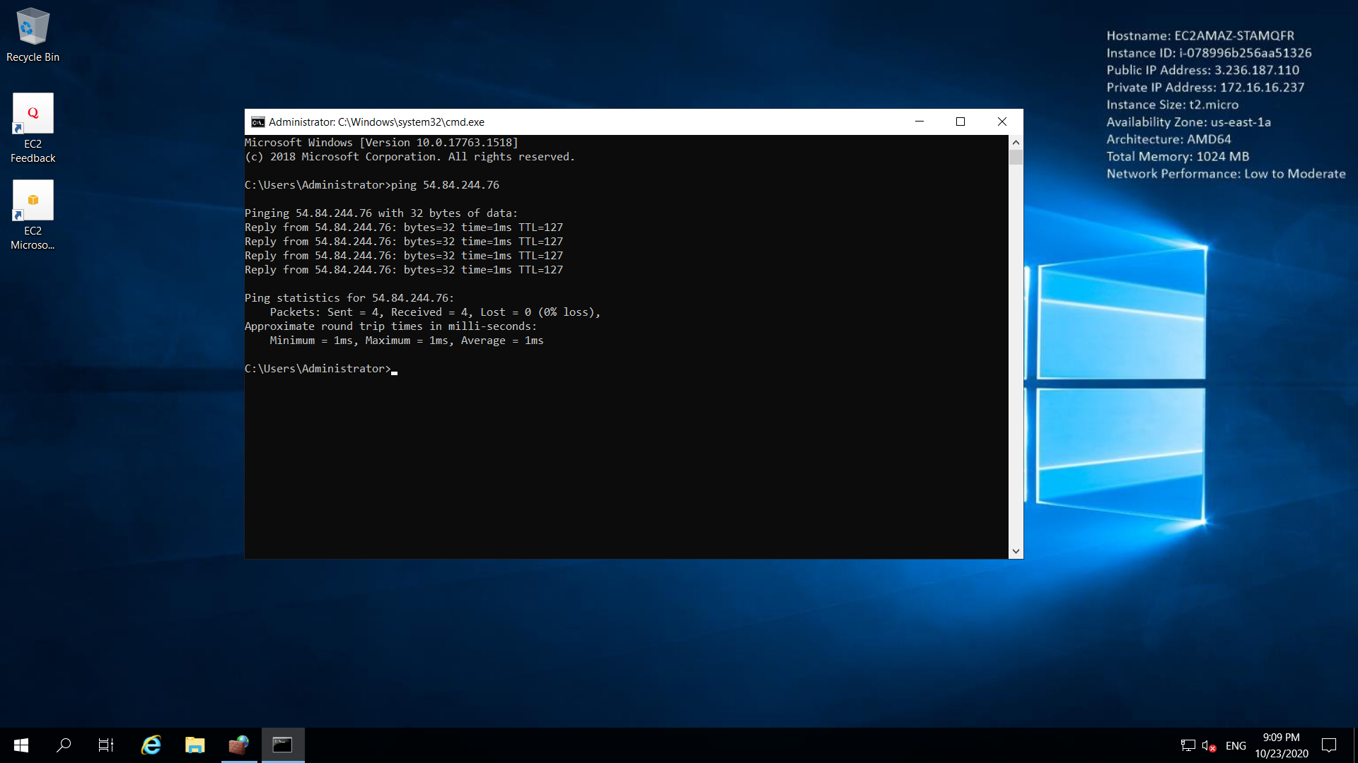

Ss8: success for private

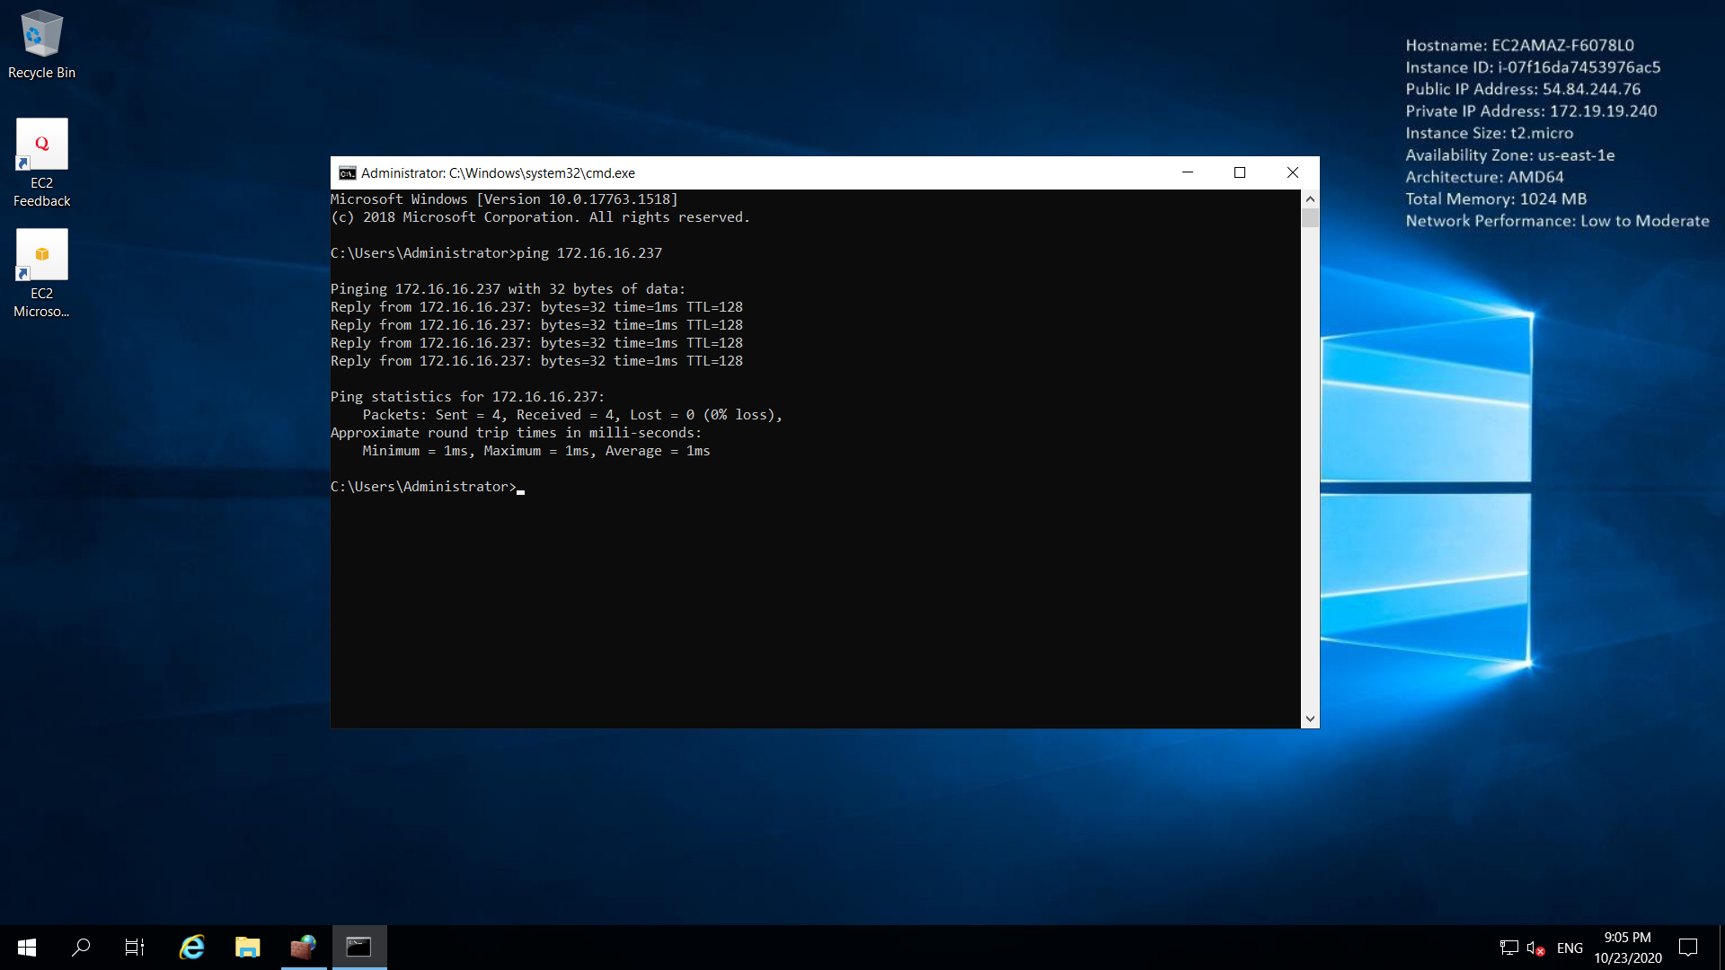

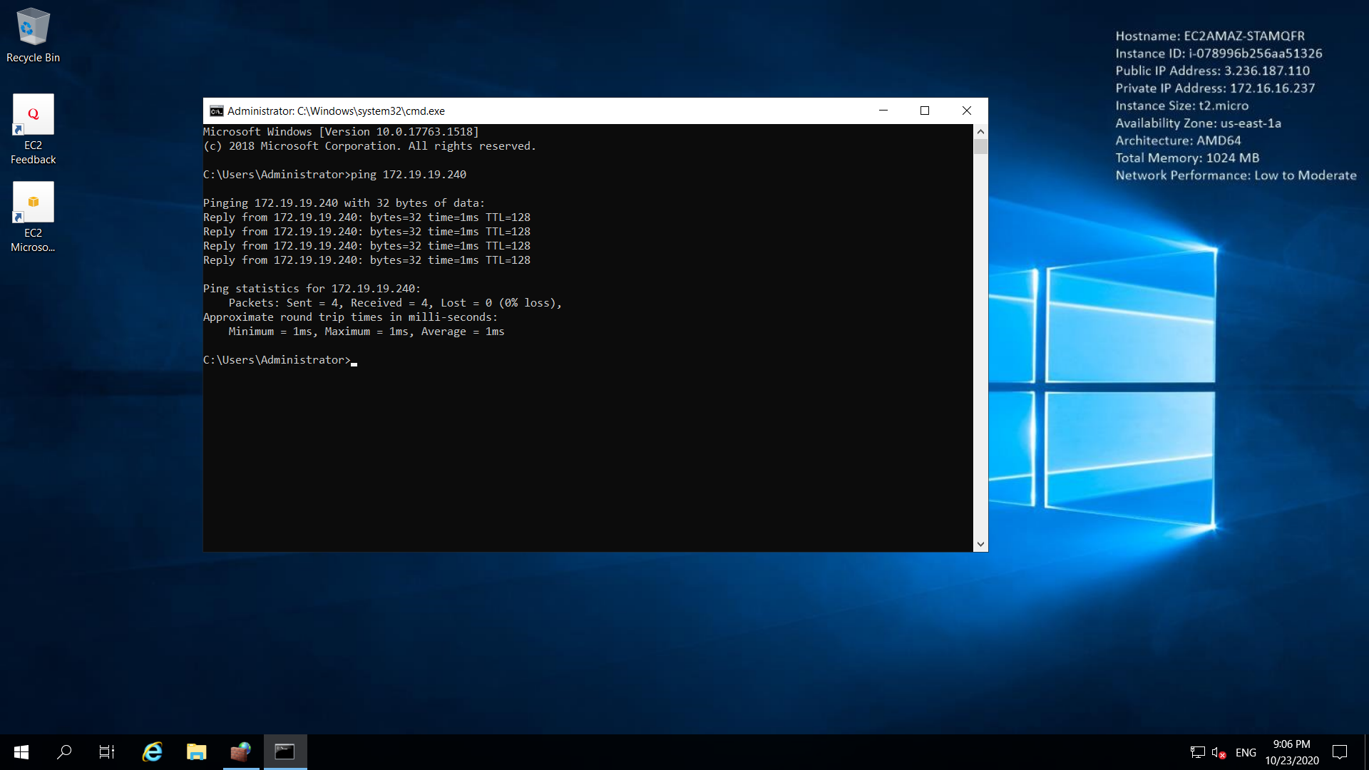

**Project 2:**

**IAM**

Task 1: Creating users without permissions-IAM password policy check.

Ss1: user summary with all tab information

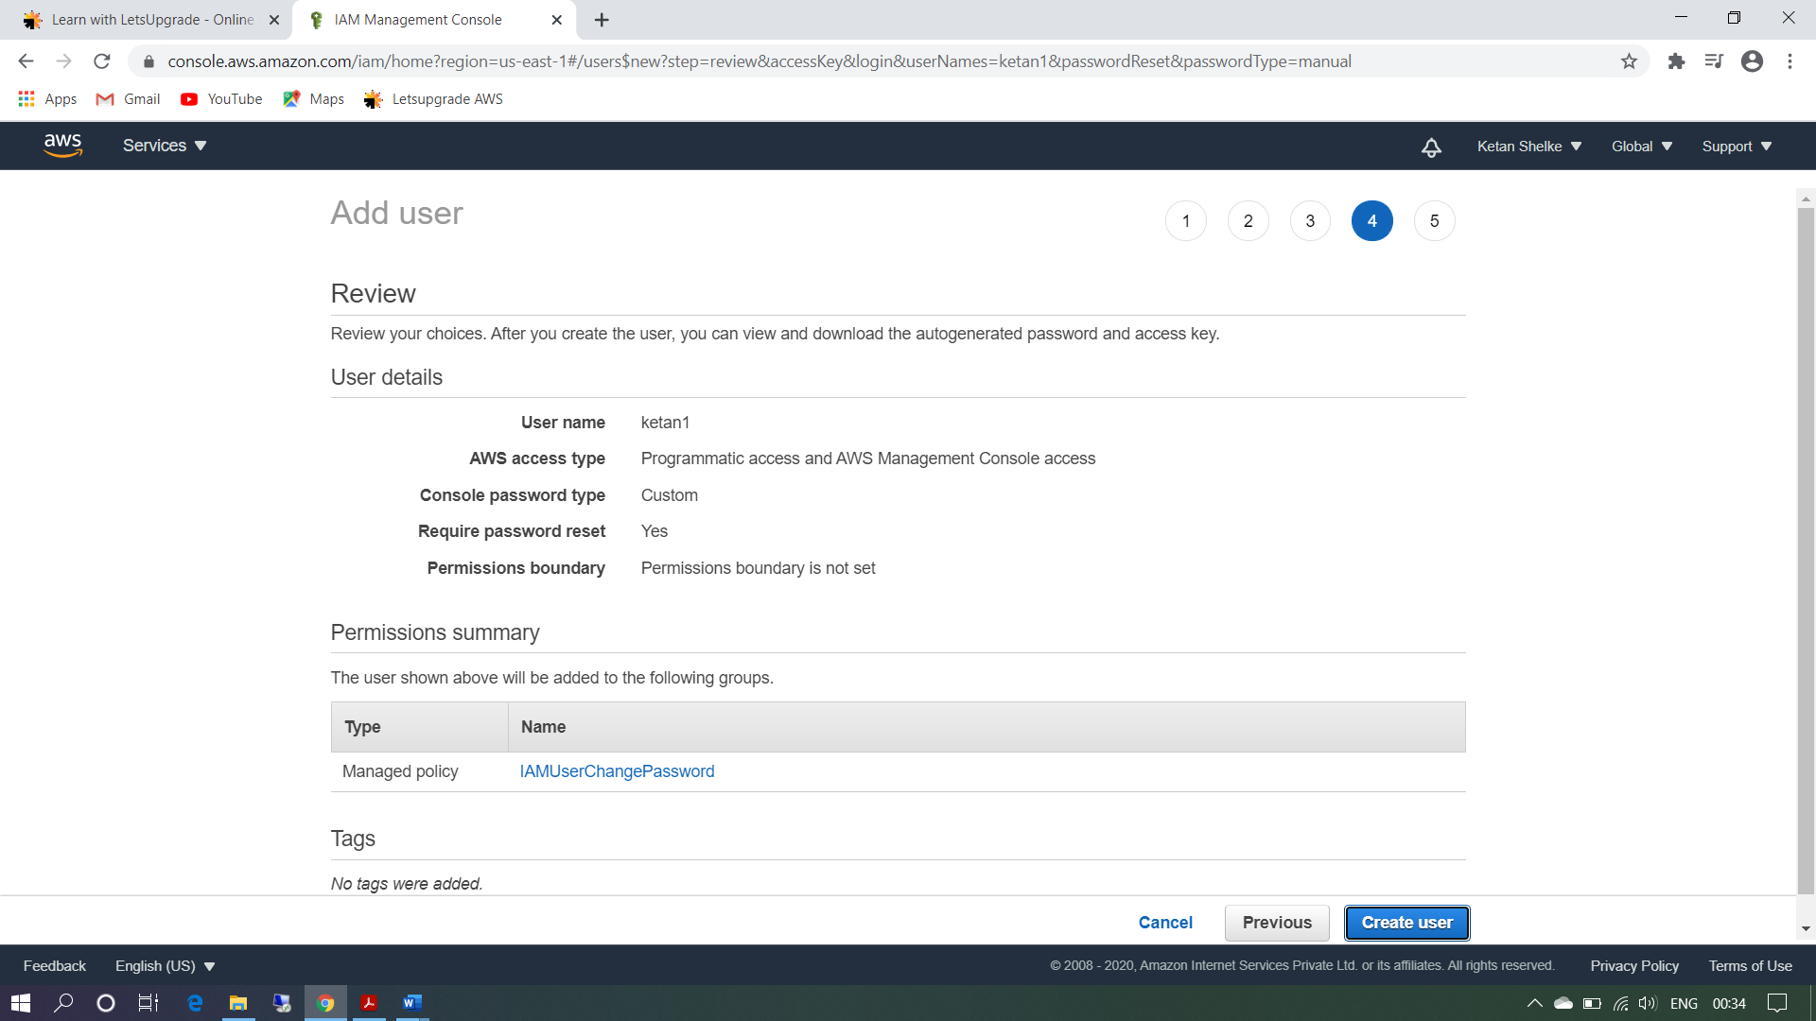

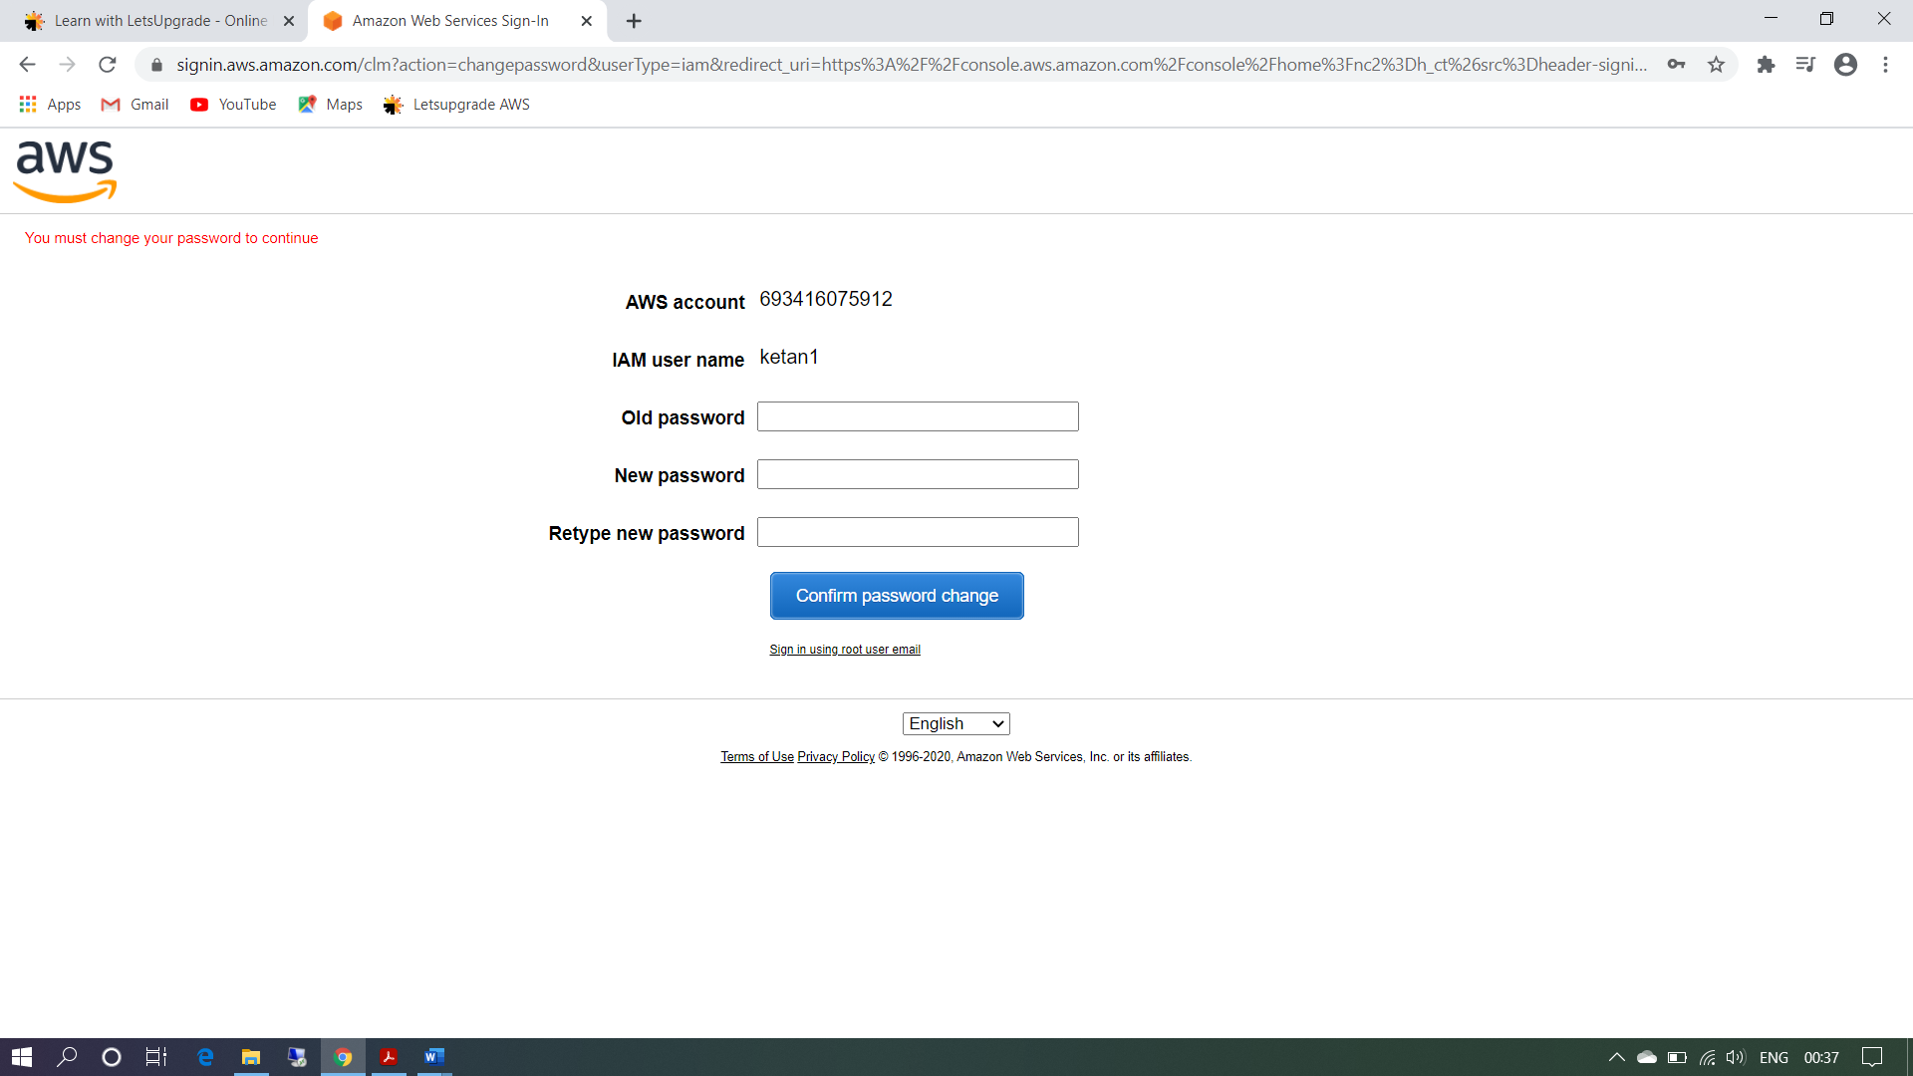

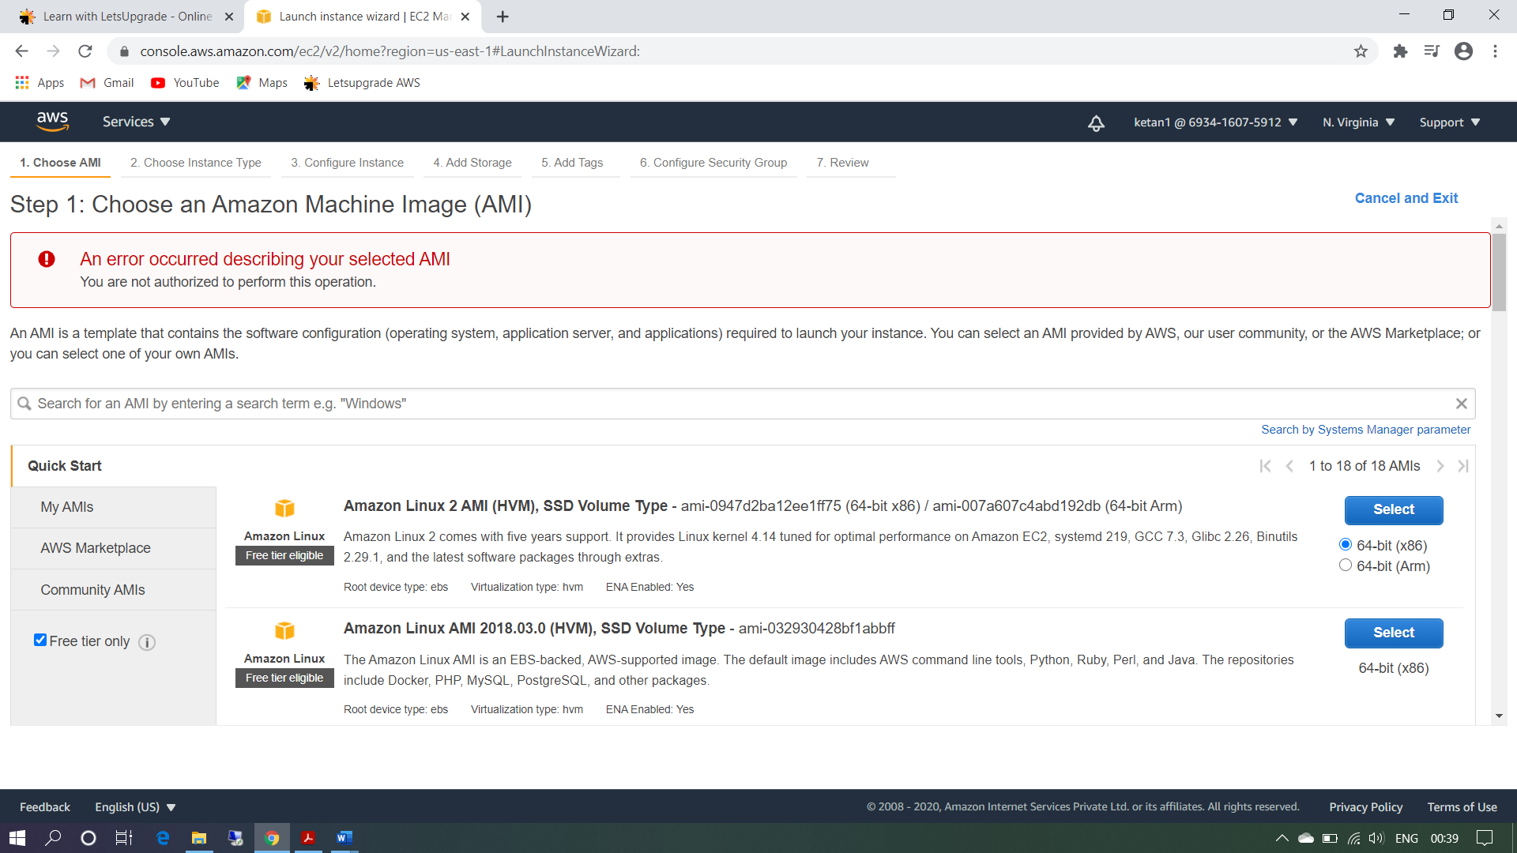

Task 2: Creating users without the IAM password policy.

Ss2: user summary with all tab information

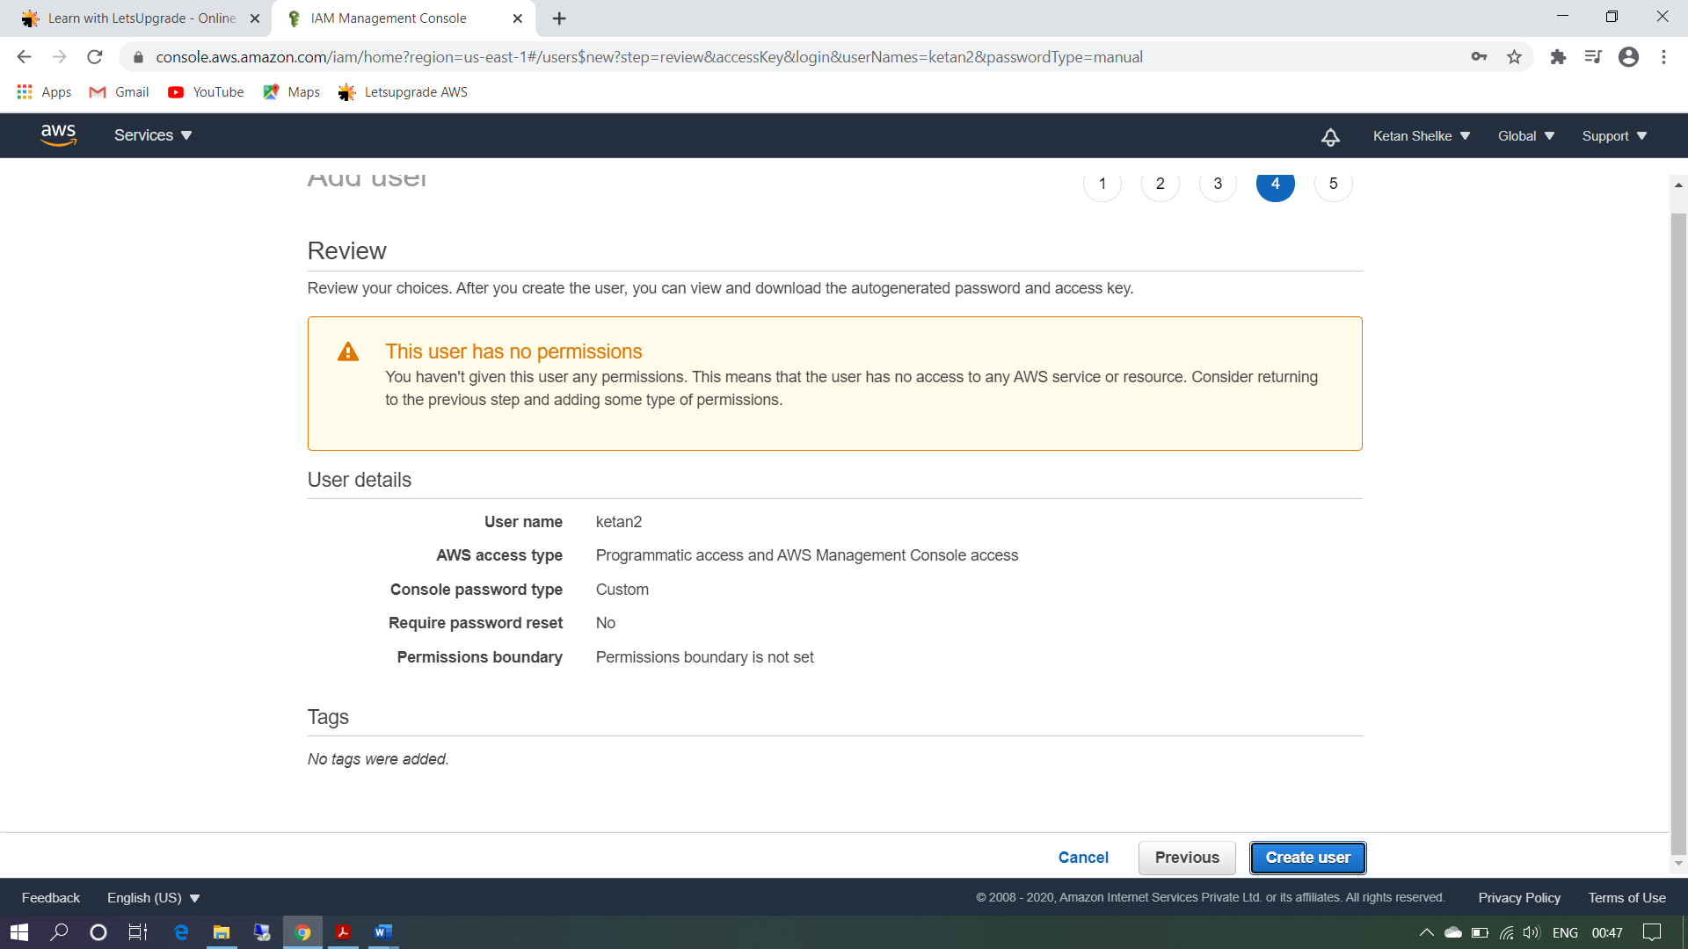

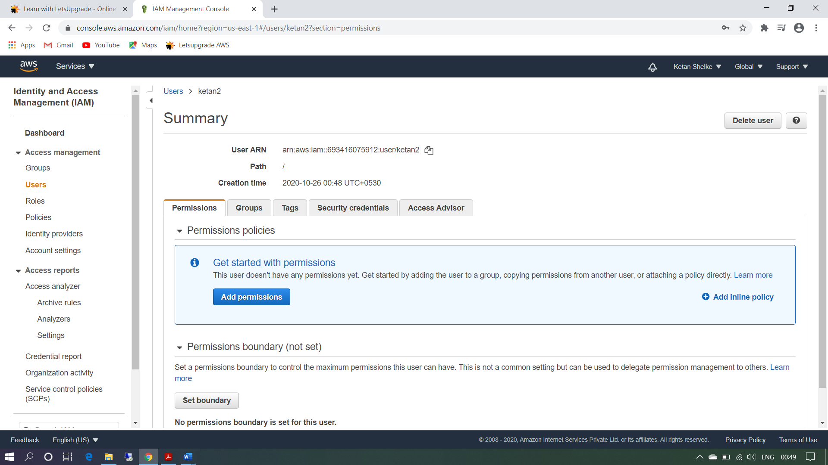

Task 3: Create a user with S3 full access

Ss3: User summary

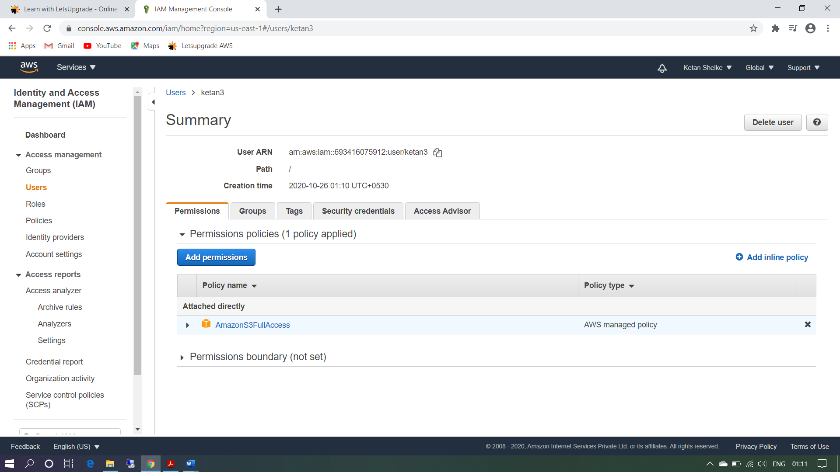

Task4: Create a group with ec2 full access

Ss4: group summary

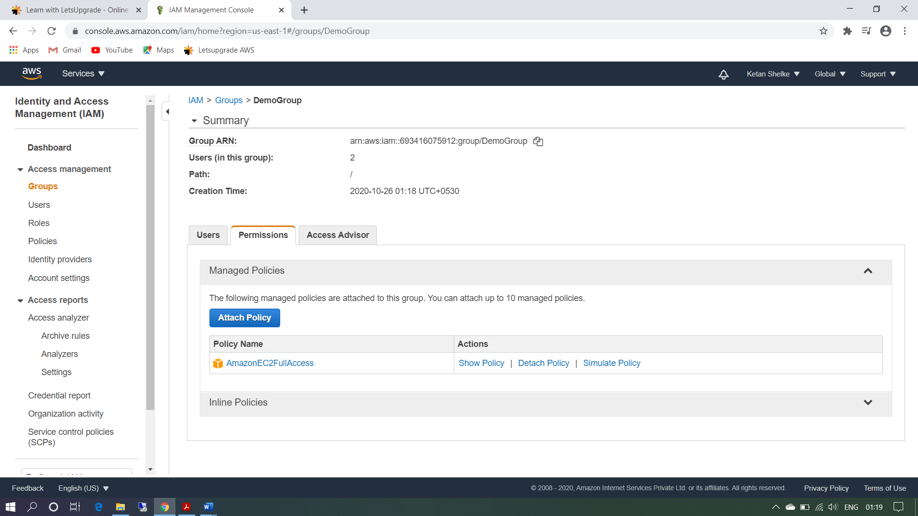

Task 5: Add user to a group and check if user policy and the group policy is reflecting on the user

Ss5: user summary with permissions

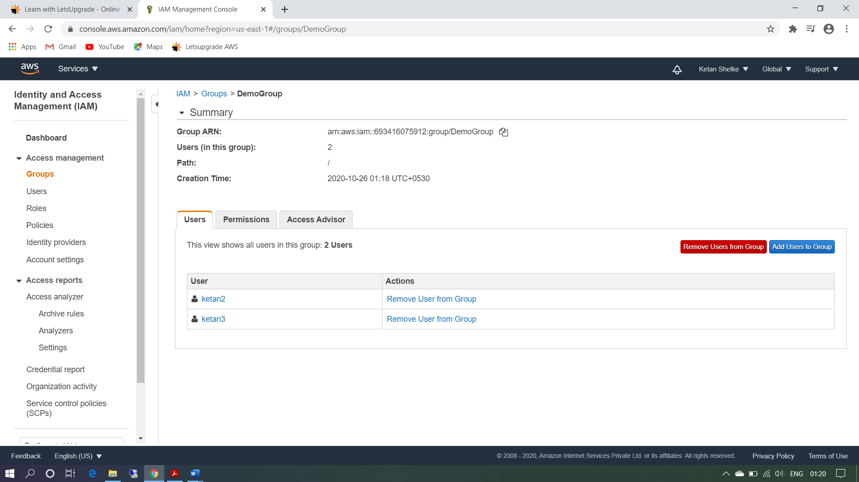

earlier there is no permission for user ketan2.now we add user ketan2 in group policy which has EC2 full access.

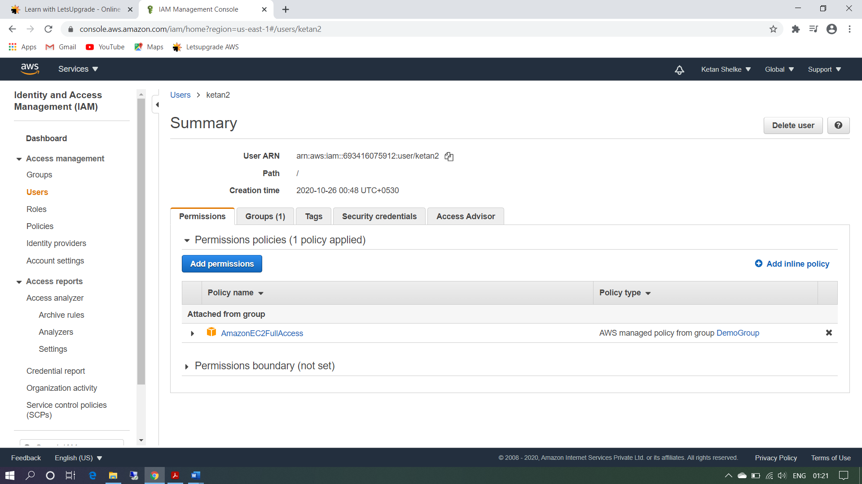

Now User ketan2 able to create instances.

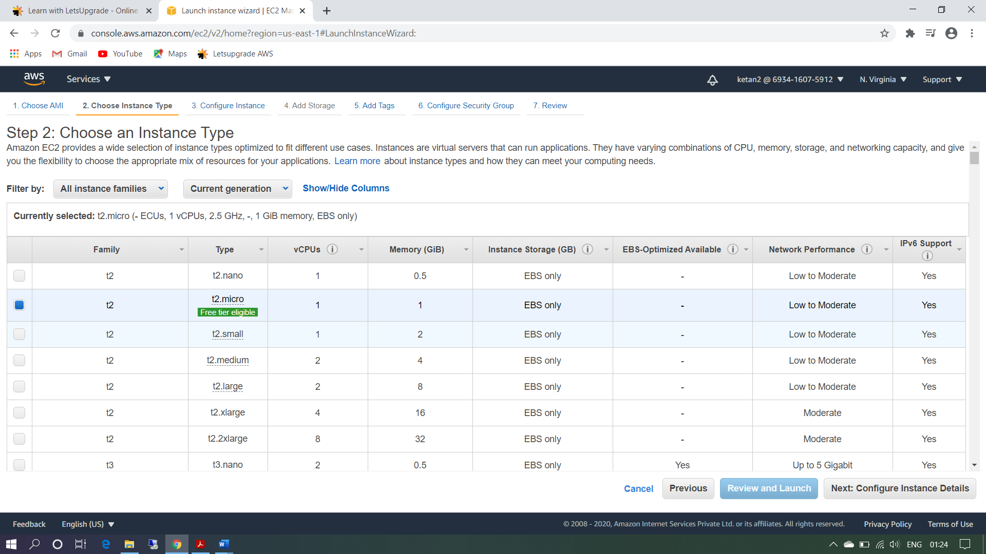

User ketan2 does not have S3 full access

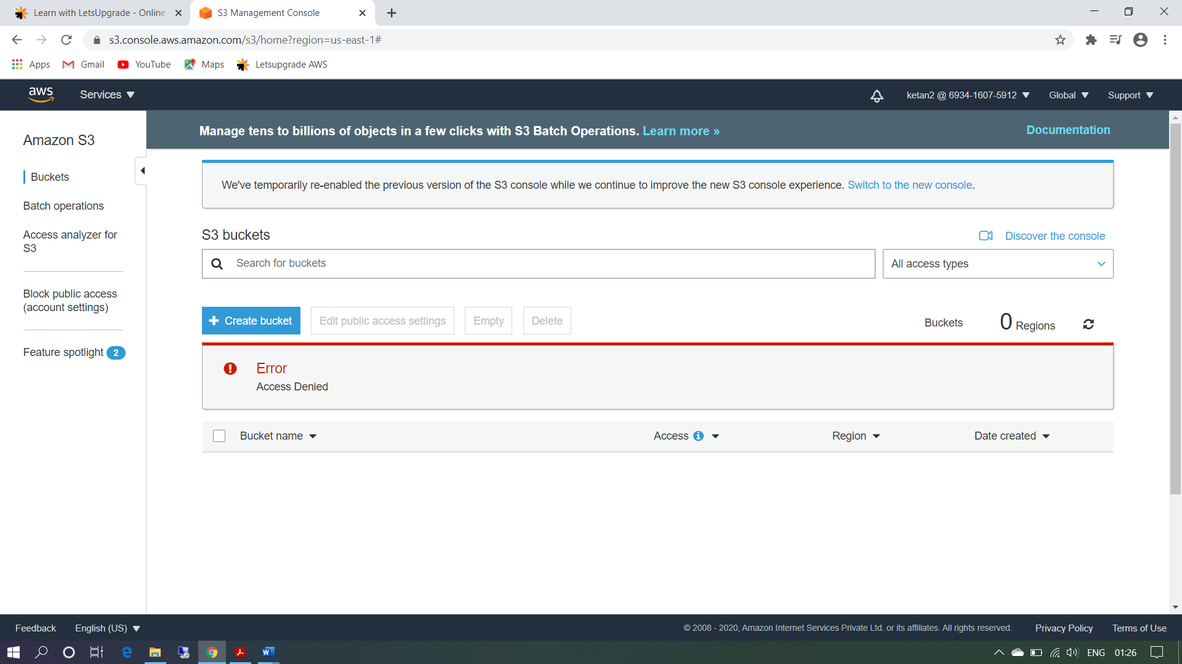

User ketan3 have there own S3 full access user policy and after adding in the group he also has EC2 full access group policy.

Ss6: login as this user show that this policy is in effect

User ketan3 have S3 full access (User Policy)

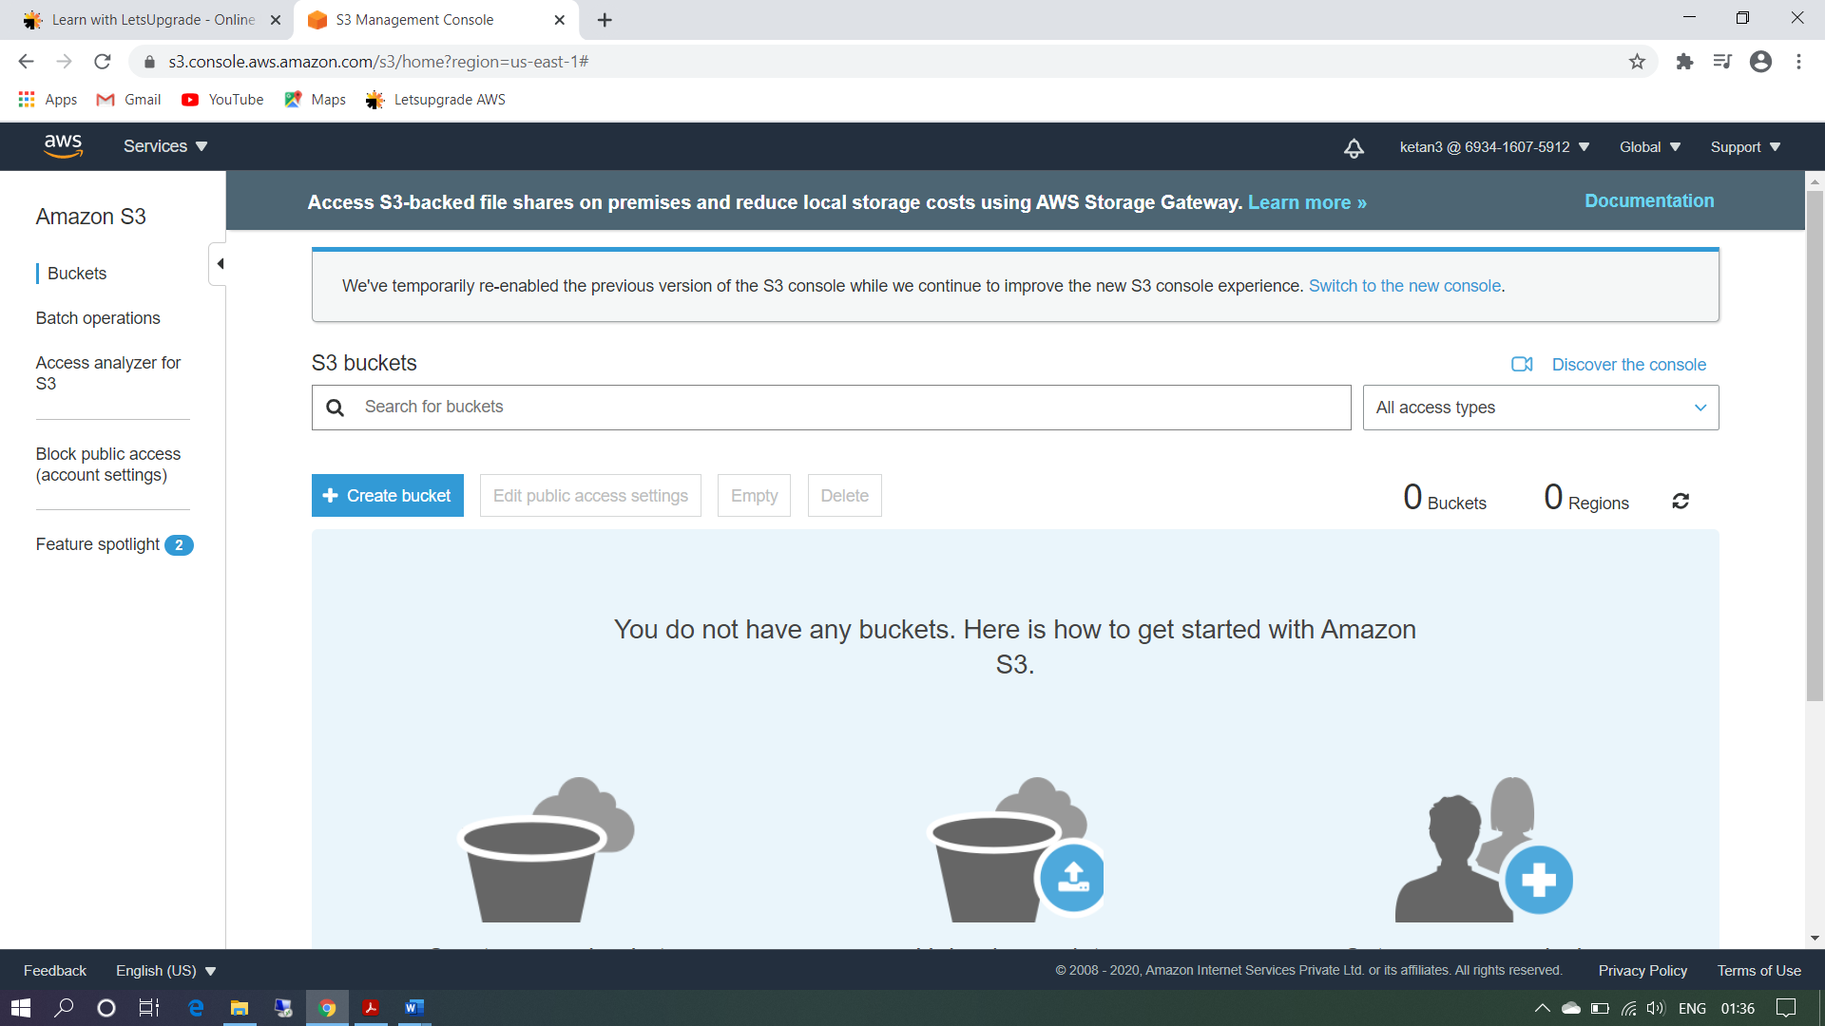

User ketan3 have EC2 access (Group Policy)

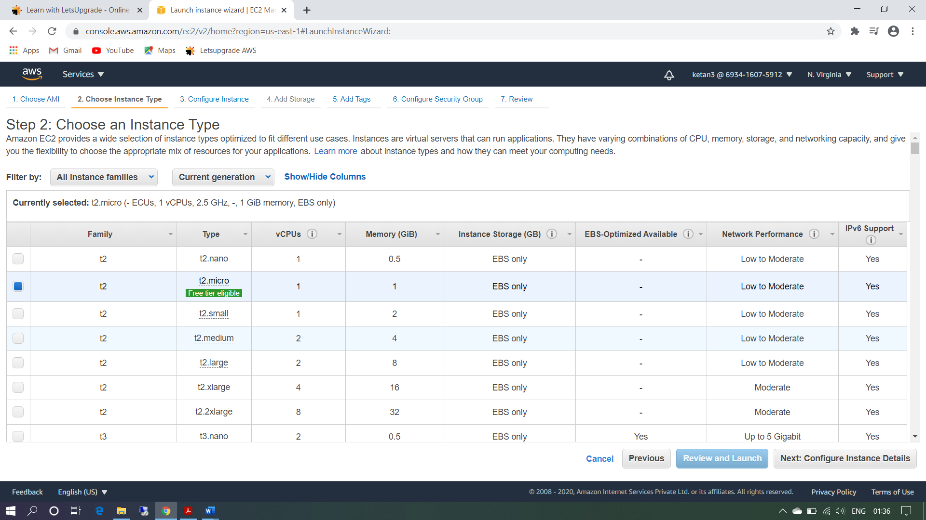

Task 6: Copy policies from the existing user

Ss7: attach user summary of the user from which you create a new user

User ketan4 permission copy from user ketan3 who has S3 and EC2 full access.

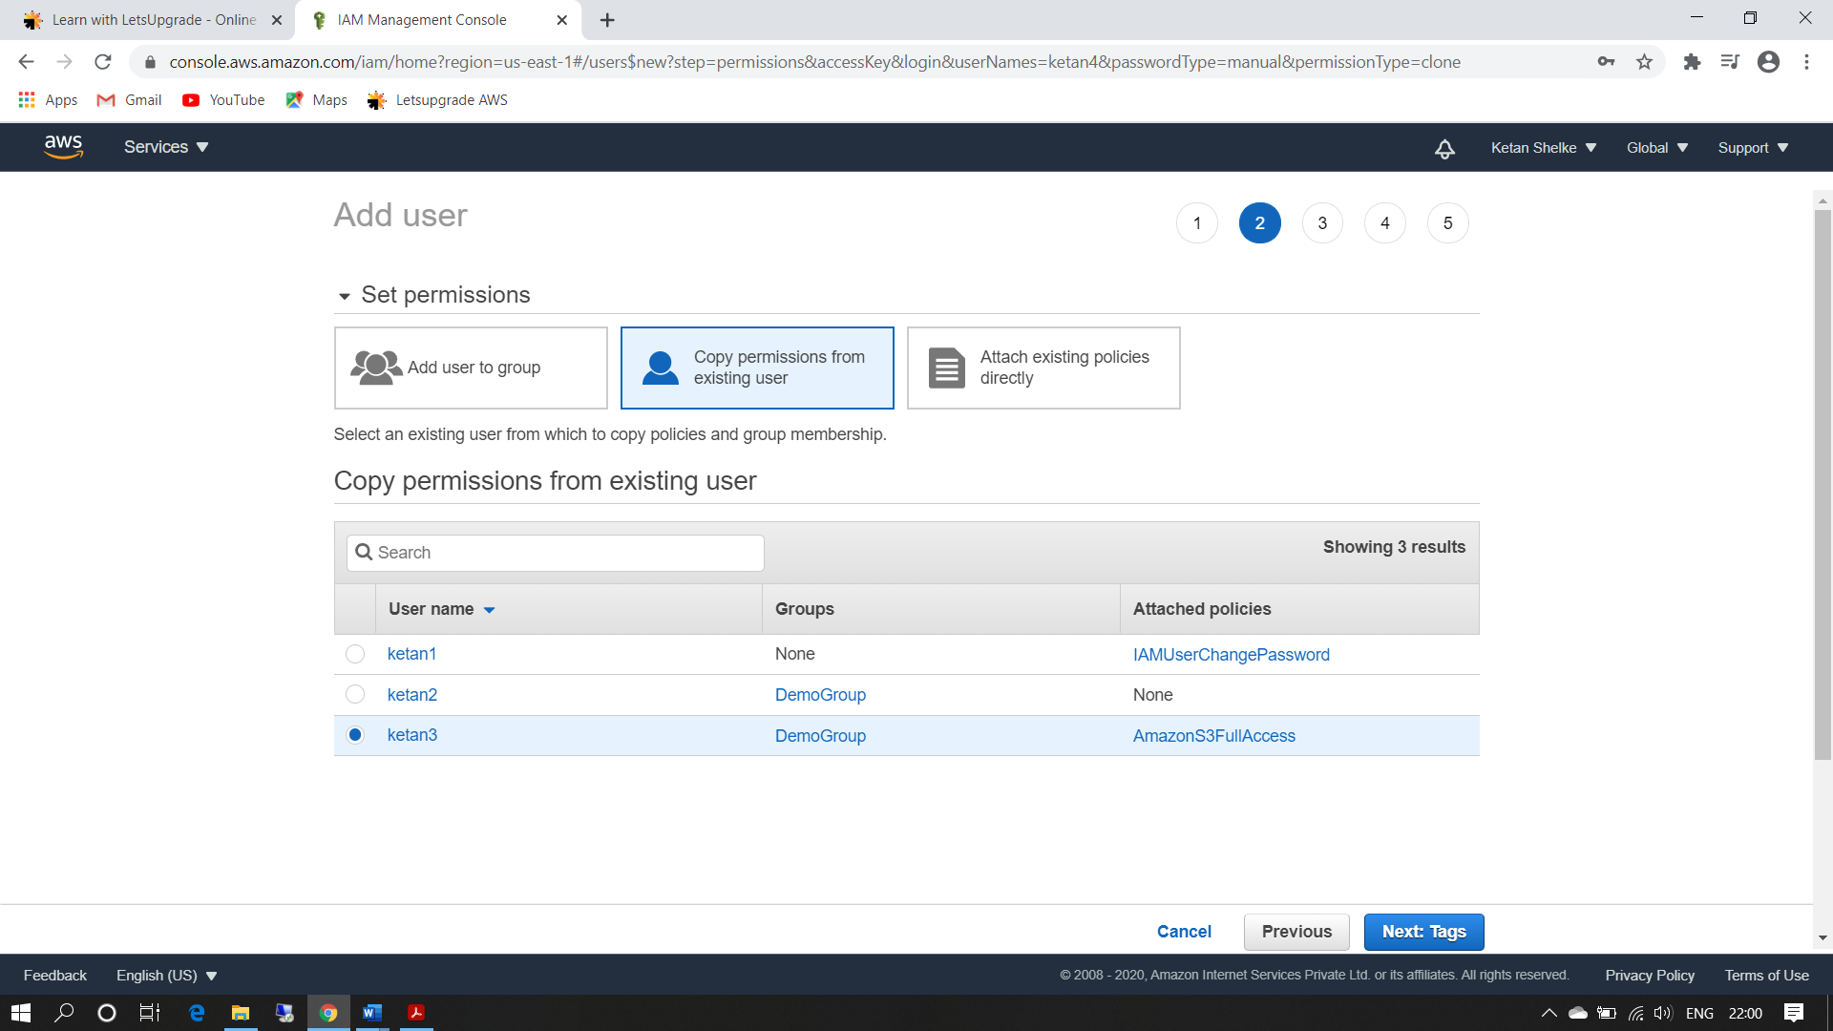

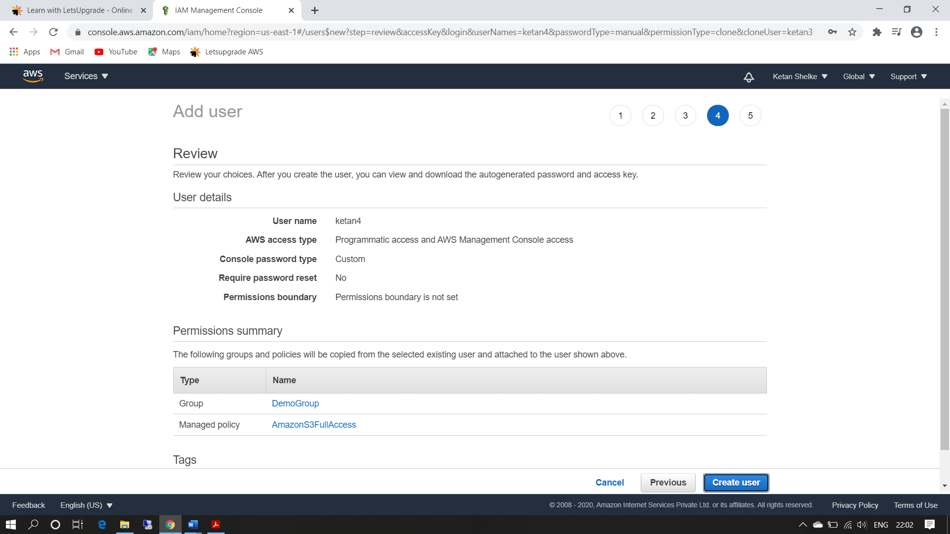

Ss8: login as this user show that this policy is in effect

Login with ketan4 user with copy permission like S3 and EC2 full access

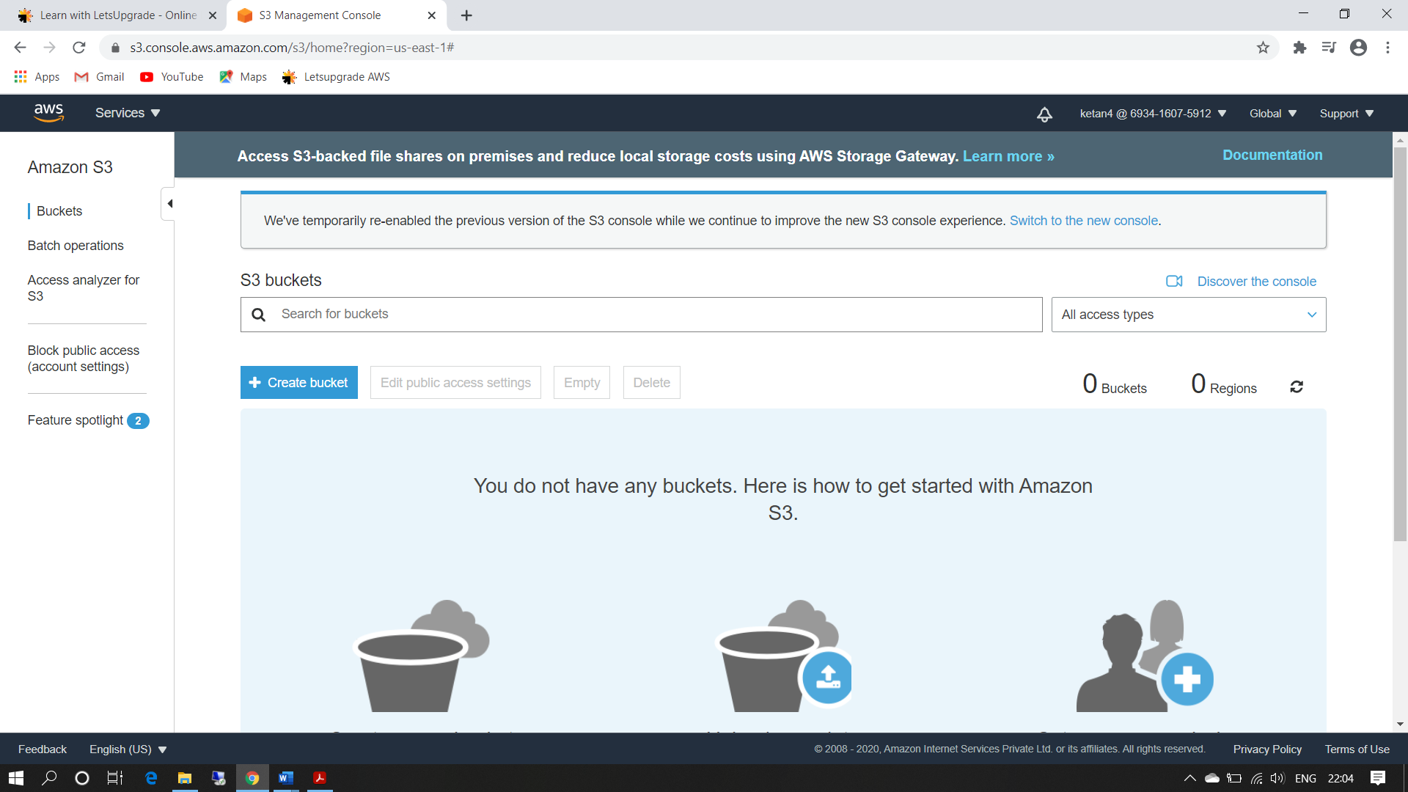

Task 7: Add user to a group in the process of creating a user

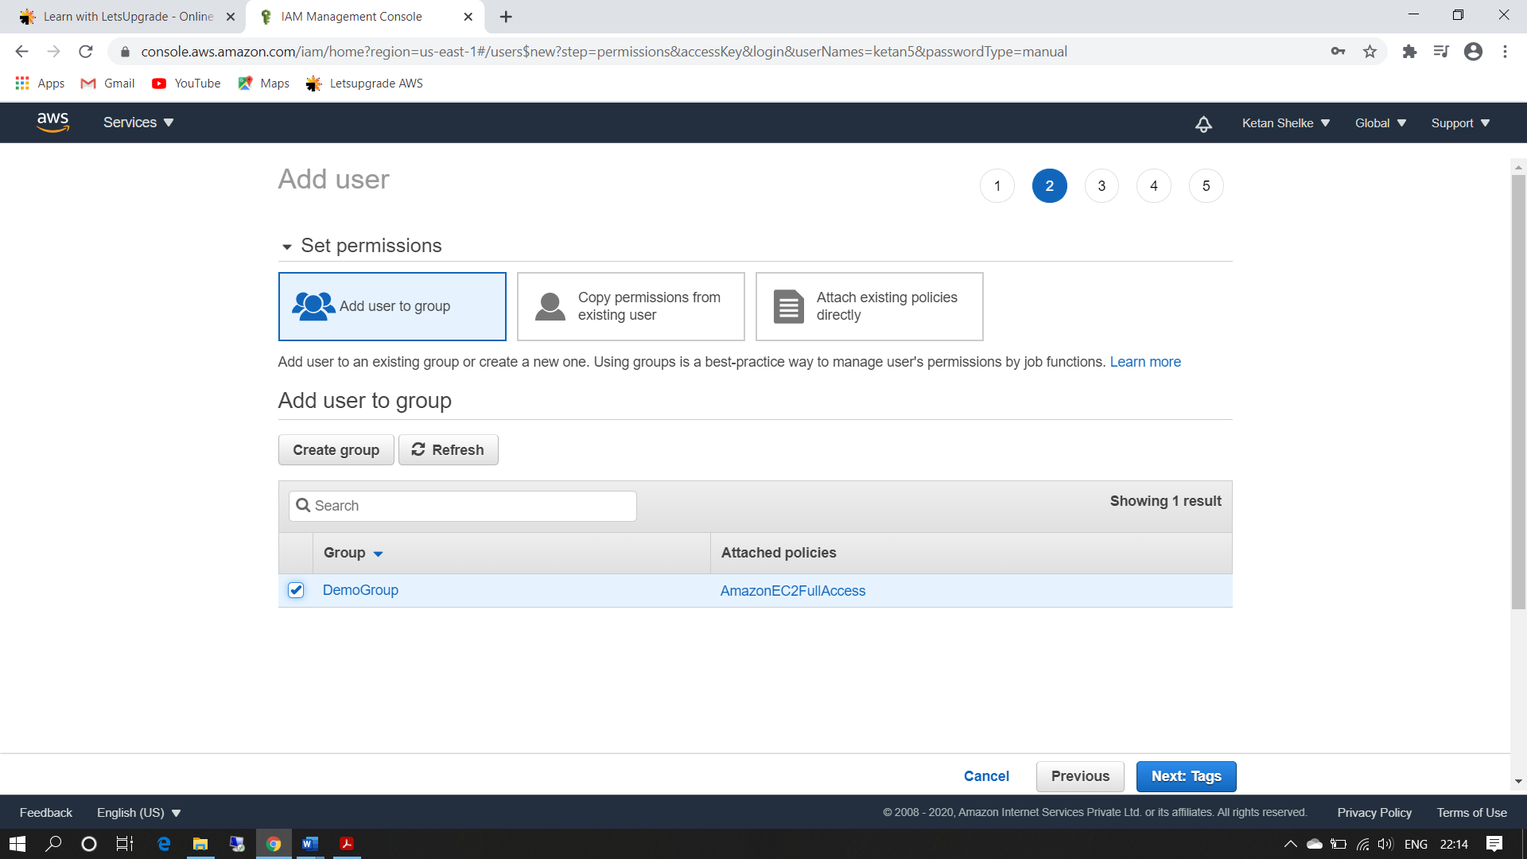

Task8: setting a password policy

Ss9: password policy screen

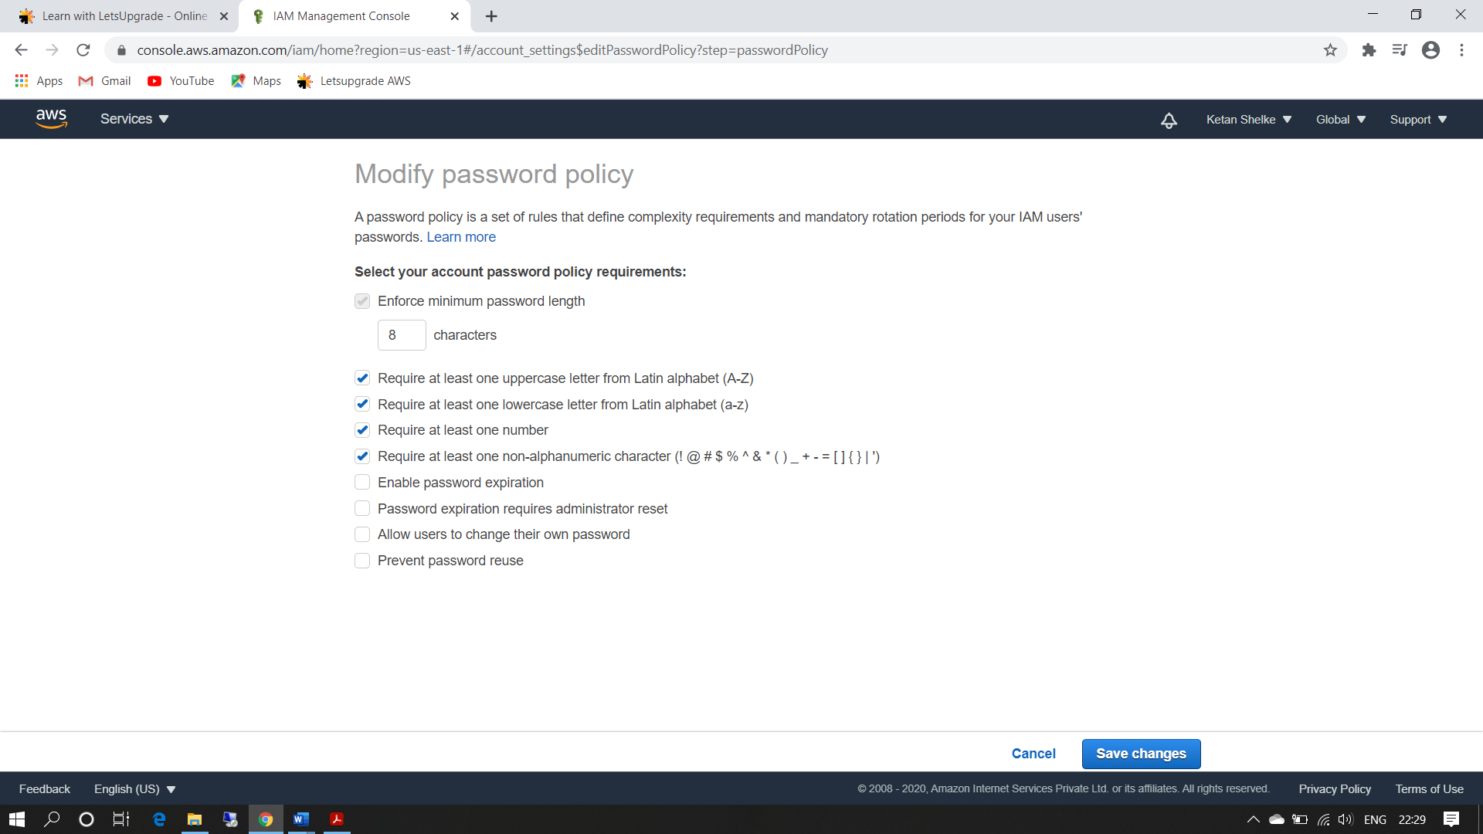

Ss10: login as the user and show password incompatibility error

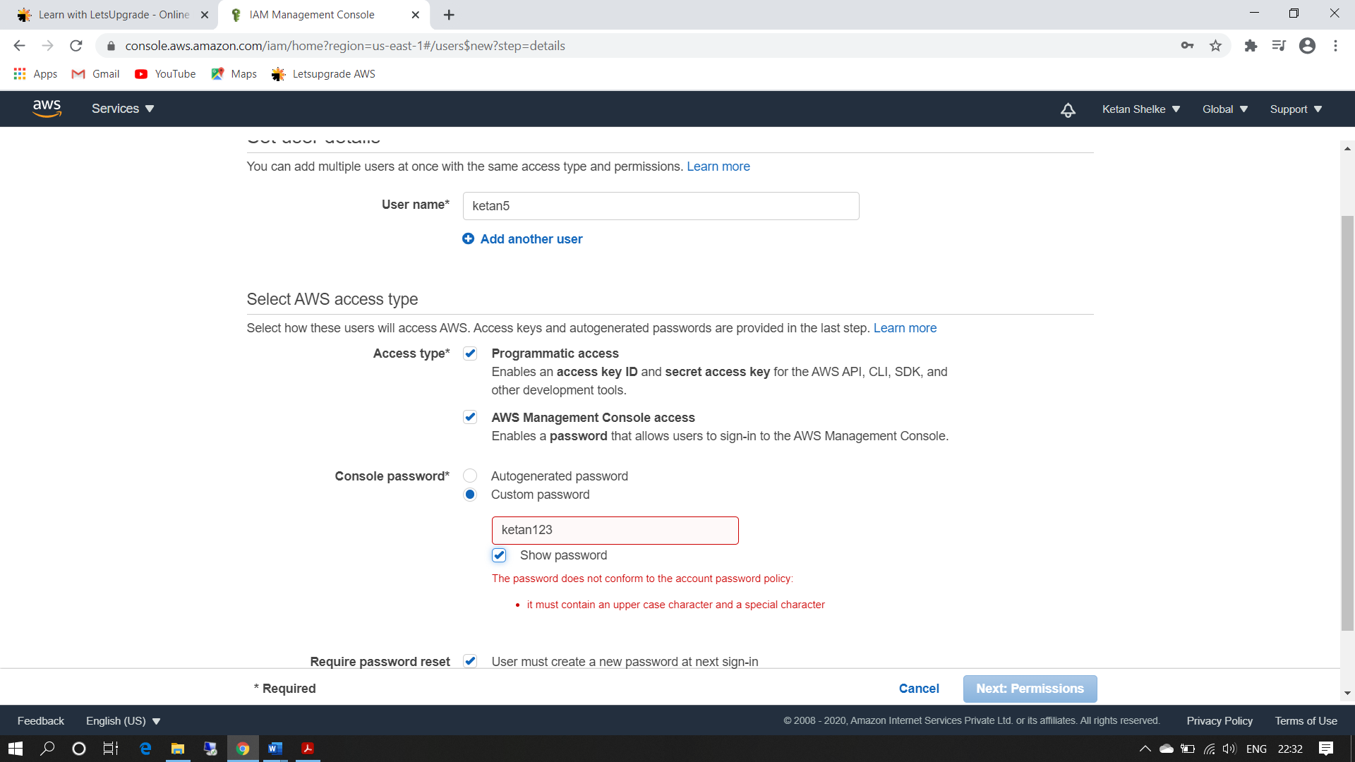

Task 9: Enabling MFA and using an MFA device

Ss11: enable MFA

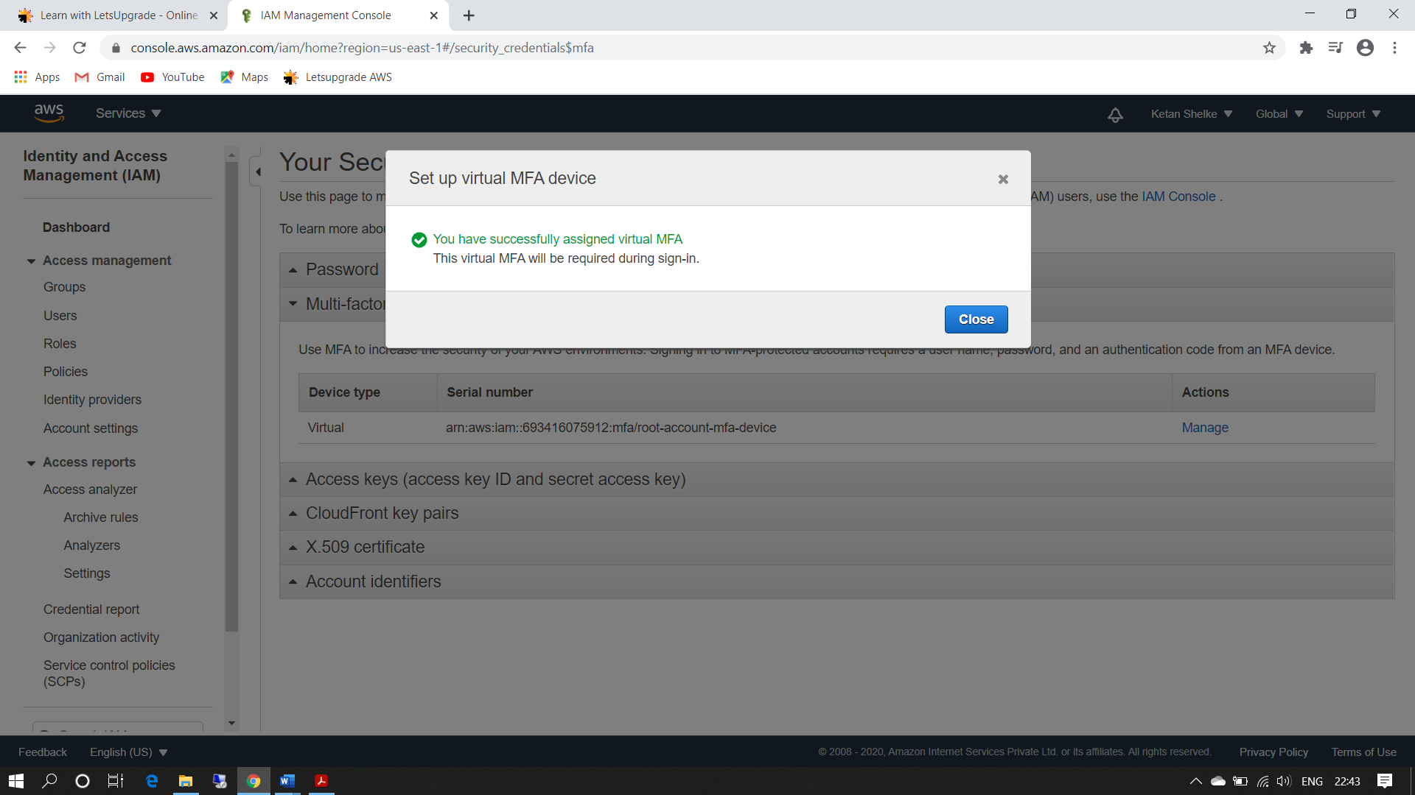

Ss12: login screen for MFA

